CES 421 M23
Assignment Week 3

As a subcontractor your company, very often, is being seen as a ”bank” by builders. These builders use your capital to finance their projects (float) but are very slow in paying you. This may increase chances of bankruptcy of your company.
How would you protect yourself before a project commences?
What are the legal avenues available to you if the builder does not comply with the Prompt Payment Laws?

Background reading:

$3.7M in long-awaited checks sent to unpaid Burke contractors
By Alan J. Keays
Oct 17 2017

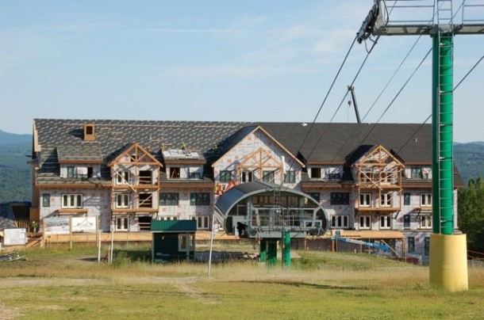
The Burke Mountain Hotel and Conference Center under construction in July 2015. File photo by Amy Ash Nixon/VTDigger
[C]contractors who helped build a $65 million hotel at the base of Burke Mountain recently received checks to cover bills as much as two years old totaling just under $3.7 million.
The payments were sent out more than 10 days ago, according to the court-appointed receiver now overseeing the resort.
But, as news of the checks and payments provide welcome financial relief to many, not all contractors who had to carry the costs of their work on their books survived the wait. Others had to cut back the number of people they employ.
Burke Mountain and another Northeast Kingdom resort, Jay Peak, are caught up in the largest investor fraud case in the history of the federal EB-5 visa program for immigrant investors.
The $3.7 million in Burke contractor payments are part of more than $100 million in checks the receiver says he has cut in the past two months. That money came from a settlement with a securities firm allegedly complicit in the scandal.
Those checks have helped clear bills, reimburse investors, finish construction projects, pay taxes and keep the two ski resorts running.
Michael Goldberg, appointed about 18 months ago as the receiver over the properties tied to the scandal, says he did his best to ensure the Burke contractors got paid in full.
Michael Goldberg, the court-appointed receiver in the EB-5 fraud case, speaks at a Statehouse news conference. File photo by Michael Dougherty/VTDigger
“All Burke contractors have received their checks. They went out over the last 10 days,” the receiver said late last week. “They got paid their full amount of what they were owed.”
The receiver added, “If you look at typical bankruptcies and receiverships, people wait four or five years to get paid 5 or 10 cents on the dollar. We got everybody paid 100 percent on the dollar in a year and a half.”
Mike Pappalardo is one business owner who said he had to sell his company, Mike’s Electric of Jay and Willison, because he could no longer stay afloat while carrying a $491,972 account receivable from Burke on his books.
At one point, to help get through it, he took a $500,000 loan from the Vermont Economic Development Authority. The state announced the loan program in June 2016 to assist contractors and subcontractors with unpaid bills associated with the alleged investor fraud case.
That loan came with requirements that also tied up $1.2 million in assets needed to secure it, Pappalardo said.
As a result, he said, “I couldn’t even get credit for bubble gum.”
That’s why, he said, he was forced to sell the company he started a quarter-century ago.
“I had no choice but to sell the company that I built, and thank God the guy bought it from me, because it kept all these jobs in Vermont,” he said.
Pappalardo said he sold the business in April to Adam Fortier, who had been the company president. It is now called MEI Electrical Contractors.
“I had 89 people working for me when I sold the company. I couldn’t last any longer,” Pappalardo said, adding he’s thankful Fortier stepped up to buy the business. “I’m very, very proud of the company. I’m very proud of Adam. He’ll do well.”
More than two dozen contractors, including many based in Vermont, had unpaid bills for their work on the Burke project. The contractors installed the heating and cooling systems, did the plumbing and roofing, and completed the wiring and masonry for the 116-unit hotel.
The unpaid bills proved a hardship for many, with some forced to close their doors, sell to new owners, or trim back workforces.
“No one ever questioned, really, the integrity of the subcontractors, and the quality of their product,” said Michael Pieciak, commissioner of the state Department of Financial Regulation.
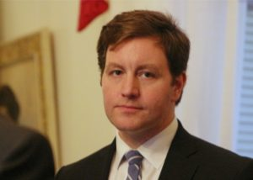
Michael Pieciak, commissioner of the Department of Financial Regulation. File photo by Erin Mansfield/VTDigger
“They were the victims, along with the investors, and many other people.”
Any business no longer in operation will receive the full amount of money it was owed for the work it did, the commissioner said.
“Whether they want to pursue other remedies is up to them,” he added.
“To get them fully repaid, not just partially repaid, and to do it in basically a year and a half, is lightning speed in these type of proceedings,” the commissioner said, adding praise for Goldberg for his work in getting that accomplished.
The Burke Mountain Hotel project was part of a series of EB-5-funded projects headed by Jay Peak owner Ariel Quiros, who also owned Burke, and his onetime business partner, Bill Stenger, Jay Peak’s former president.
Their projects provided a much-needed economic boost to the Northeast Kingdom from 2008 to 2013, putting builders and tradesmen to work constructing three hotels and three condo complexes at Jay Peak as well as other upgrades at the resort.
However, in 2014 as the developers took on projects outside of Jay Peak, including the construction of the Burke hotel, fraud allegations from investors led to news reports in VTDigger, and federal and state regulators became involved.
The developers were prevented from raising money through the EB-5 program for nine months, resulting in money drying up to pay contractors already working on the hotel.
That left the contractors with bills and the developers with no money to pay them.
Then, in April 2016, state and federal regulators leveled civil investor fraud charges against Quiros and Stenger, accusing the two men of misusing $200 million of $400 million they raised from immigrant investors seeking green cards through the EB-5 program.
Goldberg was appointed the receiver by a federal judge, but the receivership lacked the funds to pay the contractors until earlier this year. That’s when Goldberg reached a nearly $150 million settlement with the financial firm Raymond James & Associates Inc.
The money to pay the contractors comes from that settlement. That agreement resolved claims Goldberg brought over the financial services firm’s role in an alleged “Ponzi-like” scheme regulators say the two developers carried out.
However, some Burke contractors did get paid a portion of what they were owed a few months ago.
In January, the judge presiding over the U.S. Securities and Exchange Commission case against Quiros and Stenger approved a plan that offered Burke contractors a choice.
The companies could opt to get paid 33 percent of what they were owed, and hope they would be made whole in the future with proceeds from the sale of Burke. Or, according to the filing, they could take a one-time 60 percent payment of their total bill and write off the other 40 percent.
Goldberg said late last week that all the companies were made whole by the recent round of payments.
“Nobody who got paid 60 percent didn’t get paid in full,” Goldberg said. “We called them up and said, ‘We’ll give you 100 percent.’”
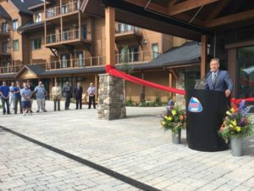
Then-Gov. Peter Shumlin speaks at a ribbon cutting for the Burke Mountain Hotel and Conference Center in September 2016. Courtesy photo
Pappalardo said his biggest frustration doesn’t necessarily rest with the receiver, or even Stenger and Quiros. He praised the two developers for spurring job growth and economic development in the Northeast Kingdom.
His company alone, he said, more than doubled in size as a result of work it did associated with the projects headed by Stenger and Quiros.
“Even today, I have no hard feelings for Bill Stenger and Ariel Quiros,” Pappalardo said.
It’s the state, he said, where he directs his blame.
As the contractors pushed to complete work on the hotel so it could open in December 2015, Pappalardo said, state officials told the contractors “not to worry” about the payments.
“They said, ‘As soon as we open it, we’ll cut you checks,’” he recalled.
In 2015, the state allowed Stenger and Quiros to continue soliciting investors under the condition that any new monies for the Burke project had to be held in escrow and payments had to be approved by a third-party administrator overseen by the Vermont EB-5 Regional Center and the Agency of Commerce and Community Development.
That led to long delays in payments to contractors who completed the Burke hotel in December 2015, though it didn’t open until August 2016.
Contractors, like Pappalardo, say they performed work on the project in good faith and were not made aware they would be on the hook while state and federal regulators investigated and brought investor fraud lawsuits against Quiros and Stenger.
Pappalardo said the state should have done more to protect and pay the contractors who had large unpaid bills. The state, he said, could have found a way to pay the contractors upfront and then get reimbursed from any settlements or when the cases against Quiros and Stenger eventually are resolved.
Instead, he said, it was the contractors whose businesses were weighed down by the large accounts receivables. And those business, Pappalardo said, employed Vermonters.
“I look at these politicians as they stand up in front of everyone and they say, ‘We’re here to create jobs,’” he said. “I’m going to look right in their eyes and say, ‘Bullshit, bullshit. You are here to make everyone seem like you really care, but you don’t.’”
The one entity that remains unpaid that worked on the Burke hotel project is the general contractor, Williston-based PeakCM.
The parties, according to Goldberg, are working to resolve that “within the next few weeks.”
Talks between the parties are well underway, the receiver said.
“PeakCM is a lot more complicated relationship,” Goldberg said, later adding, “We’re just reconciling our accounts.”
When the federal judge granted a writ of attachment request in connection with the Burke project, the order stated PeakCM was owed almost $3.92 million, which included the nearly $3.7 million owed to the subcontractors.
Sandy Fead, PeakCM’s attorney, said last week that PeakCM’s matter is a little more complicated because the company did work on other projects led by Quiros and Stenger.
“We’re tying all of those things together, and they’re not fully resolved yet,” Fead said.

The General Contractor Did Not Pay the Subcontractor in Texas

