PME 603

Lecture Notes

11/17/20

Product Launch Checklist

An Example

The following serves as a checklist for product launch activities:

Planning
- A product launch plan has been prepared covering all activities to be performed by Engineering, Manufacturing, Marketing, Sales, Product Support, and Field Service.
- Functional departments understand their responsibilities for launch activities.
- Functional departments have committed the necessary resources to support launch activities.
- The launch activities are on track to be completed as currently planned.
- A Production Readiness Review, Product Launch Review or related gate review confirms that all preparations have been completed and the product is ready to launch.

Technical
- Product performance has been evaluated through testing and qualification and the product meets its defined requirements.
- The product and the production process have been qualified or validated and all regulatory approvals and/or certifications have been obtained.
- All product design documentation has been completed and approved.
- The product documentation is under configuration control.
- Technical data sheets have been prepared.
- User documentation, operating manuals and maintenance instructions have been completed.
- Engineering personnel stand ready to address any issues that arise.

Operations/Procurement
- Required manufacturing process documentation or outputs (e.g., work instructions, CNC programs, manning plans, etc. are complete.
- New tooling and equipment have been qualified/validated
- Production processes have been proven/qualified/validated using either pilot production lines or actual production lines.
- Production workers have been trained or training is planned to support initiation of production.
- The product and demand forecast data has been established in the enterprise resource planning (ERP) system and ERP is used to plan and manage the supply chain and production.
- All suppliers have been selected and qualified.
- Needed materials and parts are on-order or in stock.
- Adequate capacity and personnel exist to support planned production.
- The distribution pipeline is filled with the appropriate level of product.

Marketing and Sales
- Market receptivity has been evaluated by key customer feedback, focus groups, test markets, or beta tests prior to launch.
- If the product is being used by beta customers, testimonials or case studies have been prepared.
- A promotion and advertising plan has been developed.
- Advertising copy has been developed and media contracts and arrangements have been made.
- Promotional materials and sales literature have been developed, ordered, and are ready to distribute.
- Sales and distribution channels have been identified and established.
- Sales personnel have been trained.
- Sales personnel have the needed sales literature, sales support material and product samples.
- Product pricing has been established and approved.
- Final packaging has been designed, approved, and ordered.
- The sales forecast has been updated based on the latest forecast of market demand.
- The website has been updated.
- Press releases have been prepared and are ready to distribute.
- Industry analysts or other influential personnel have been briefed as planned.
- A product release and/or general availability has been announced.

Product Support
- Necessary support resources are hired and in place.
- Service and support personnel have been trained or a phased training program is underway.
- Frequently asked questions (FAQ’s) have been identified and responses prepared.
- Troubleshooting guides, installation guides, and service manuals have been prepared.
- Spare part requirements have been planned.

Commercialized Product Marker Performance

Analysis

What is A BCG Matrix? Definition, Guide and Examples
by Gary Fox

The BCG Matrix, otherwise known as the growth share matrix, is a portfolio management framework that helps companies decide how to strategically manage a portfolio of products or services.

How to use the BCG Matrix model ?
The Boston Consulting Group’s product portfolio matrix (BCG matrix) is designed to help with long-term strategic planning, to help a business consider growth opportunities by reviewing its portfolio of products to decide where to invest, to discontinue or develop products. It’s also known as the Growth/Share Matrix.
The Matrix is divided into 4 quadrants. Each quadrant represents a relative position based on market growth and relative market share.
The BCG is more relevant to larger organizations with multiple services and markets. However, smaller businesses that have a broad range of products can use this to analyze their products.
Often the 80:20 rule applies. In other words, eighty per cent of profits come from twenty per cent of the products and therefore the BCG matrix provides a method to analyze your portfolio and decisions.

What are the four quadrants of the BCG Matrix?
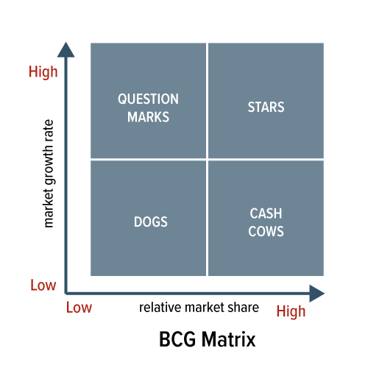

The Four Quadrants Explained

Dog products: The recommended advice is to remove any dogs from your product portfolio as they are a drain on resources. However, this can be an over-simplification since it is possible to generate ongoing revenue with little cost. For example, in the automotive sector, when a car line ends, there is still an after-market i.e. the need for spare parts. After SAAB ceased trading and producing new cars, a whole business emerged providing SAAB parts.

Question mark products: As the name suggests, these products often require significant investment to push them into the star quadrant. The challenge is that a lot of investment may be required to get a return. For example, Amazon developed the Firephone but failed to gain traction in the smartphone market. Despite a serious amount of investment, it flopped and failed to compete against the established players such as Apple and Samsung.

Star products:Can be the market leader though require ongoing investment to sustain. They generate more ROI than other product categories.

Cash cow products: The simple rule here is to ‘Milk these products as much as possible without killing the cow! Often mature, well-established products. The company Procter & Gamble which manufactures Pampers nappies to Lynx deodorants has often been described as a ‘cash cow company’.

Advantages and disadvantages of the BCG Matrix
Benefits of the matrix:
- Easy to perform;
- Helps to understand the strategic positions of a business portfolio;
- It is a good starting point prior to further analysis.

Growth-share analysis oversimplifies the factors involved in assessing the future of a business portfolio. Some other limitations include:
- Business can only be classified to four quadrants. It can be confusing to classify an SBU that falls right in the middle.
- It does not define what ‘market’ is. Businesses can be classified as cash cows, while they are actually dogs, or vice versa.
- Does not include other external factors that may change the situation completely.
- Market share and industry growth are not the only factors of profitability. Besides, high market share does not necessarily mean high profits.
- It denies that synergies between different units exist. Dogs can be as important as cash cows to businesses if it helps to achieve competitive advantage for the rest of the company.

BCG Matrix Example
The BCG Model is based on products rather than services, however, it does apply to both. You could use this if reviewing a range of products, especially before starting to develop new products.
Looking at the British retailer, Marks & Spencer, they have a wide range of products and many different lines. We can identify every element of the BCG matrix across their ranges:
- Stars
Example: Lingerie. M&S was known as the place for ladies underwear at a time when choice was limited. In a multi-channel environment, M&S lingerie is still the UK’s market leader with high growth and high market share.
- Question Marks/Problem Child
Example: Food. For years M&S refused to consider food and today has over 400 Simply Food stores across the UK. Whilst not a major supermarket, M&S Simply Food has a following which demonstrates high growth and low market share.
- Cash Cows
Example: Classic range. Low growth and high market share, the M&S Classic range has strong supporters.
- Dogs
Example: Autograph range. A premium-priced range of men’s and women’s clothing, with low market share and low growth. Although placed in the dog category, the premium pricing means that it makes a financial contribution to the company.

How the BCG Matrix Fits with Other Forms of Analysis
The BCG Matrix is a portfolio level of analysis. The two other types of analysis related to this are the Ansoff Matrix and the product lifecycle.
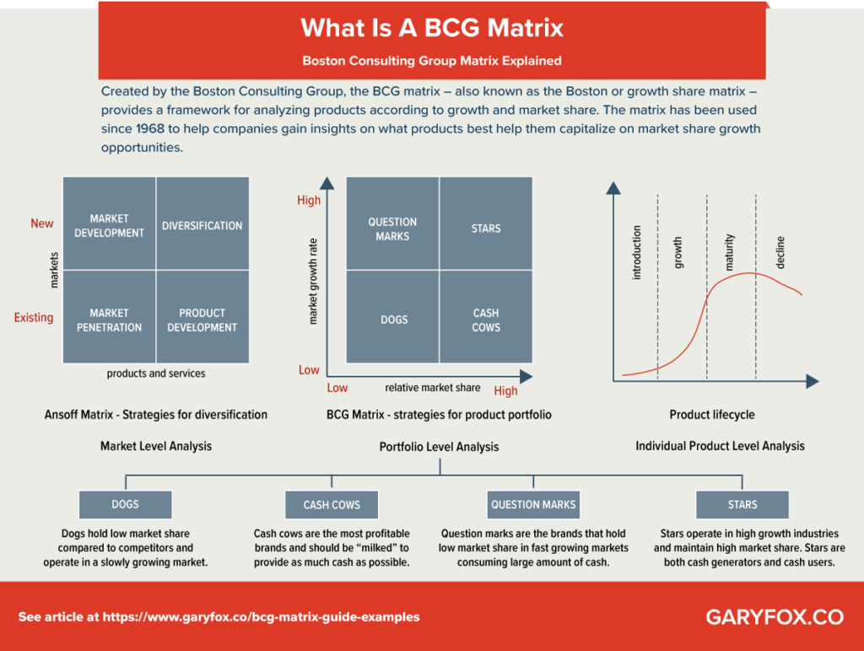

Better Methods:

S-curves Discrete Rates of Growth

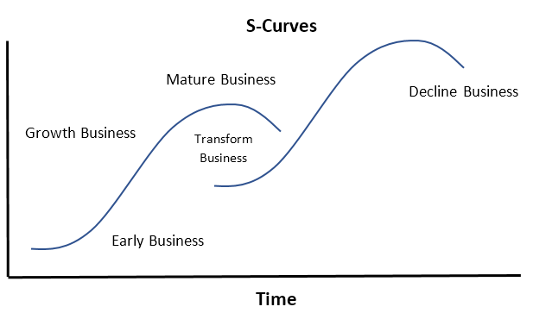

S-curves cumulative
$
Rate of Change
Market Potential
Time
Profits
Costs
Revenue
Market Share

