Understanding Global Change Source; University of California Berkely

UNDERSTANDING GLOBAL CHANGE
Discover why the climate and environment changes, your place in the Earth system, and paths to a resilient future.

Earth’s spin, tilt and orbit
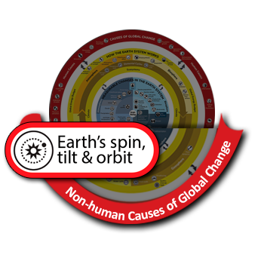
Earth’s spin, tilt, and orbit affect the amount of solar energy received by any particular region of the globe, depending on latitude, time of day, and time of year.
Small changes in the angle of Earth’s tilt and the shape of its orbit around the Sun cause changes in climate over a span of 10,000 to 100,000 years, and are not causing climate change today.
Daily changes in light and temperature are caused by the rotation of the Earth, and seasonal changes are caused by the tilt of the Earth. As the Earth orbits the Sun, the Earth is pulled by the gravitational forces of the Sun, Moon, and large planets in the solar system, primarily Jupiter and Saturn. Over long periods of time, the gravitational pull of other members of our solar system slowly change Earth’s spin, tilt, and orbit. Over approximately 100,000 – 400,000 years, gravitational forces slowly change Earth’s orbit between more circular and elliptical shapes, as indicated by the blue and yellow dashed ovals in the figure to the right. Over 19,000 – 24,000 years, the direction of Earth’s tilt shifts (spins). Additionally, how much Earth’s axis is tilted towards or away from the Sun changes through time, over approximately 41,000 year cycles. Small changes in Earth’s spin, tilt, and orbit over these long periods of time can change the amount of sunlight received (and therefore absorbed and re-radiated) by different parts of the Earth. Over 10s to 100s of thousands of years, these small changes in the position of the Earth in relationship to the Sun can change the amount of solar radiation, also known as insolation, received by different parts of the Earth. In turn, changes in insolation over these long periods of time can change regional climates and the length and intensity of the seasons. The Earth’s spin, tilt, and orbit continue to change today, but do not explain the current rapid climate change.
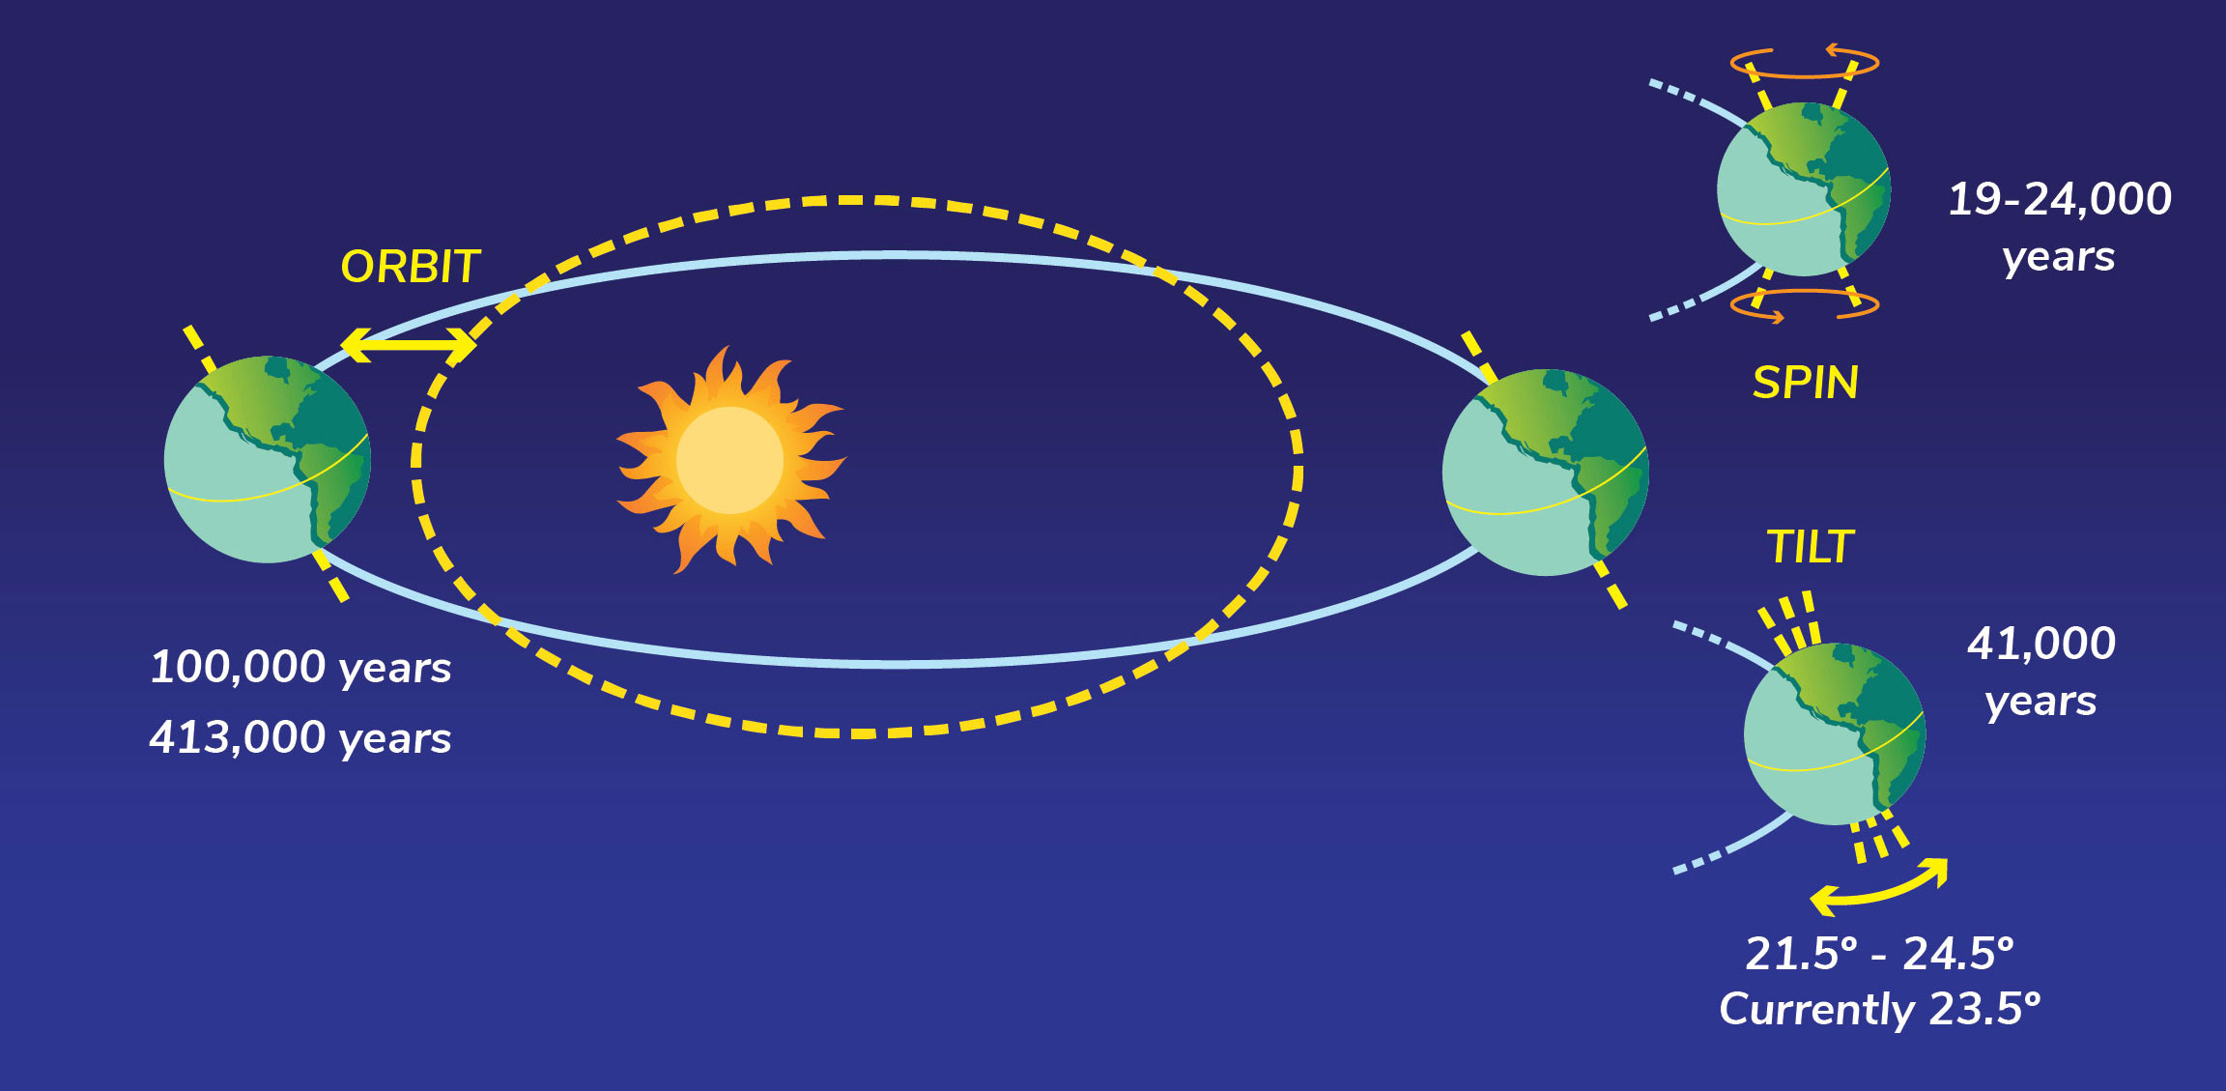
Adapted from Universe Today.
Changes in insolation result in cycles of ice ages, during which ice sheets expand (glacial periods) and contract (interglacial periods). These patterns of ice ages, also called Milankovitch cycles, were predicted by the Serbian scientist Milutin Milankovitch. Milankovitch predicted that glacial periods occur during times of low summer insolation at high latitudes in the northern hemisphere, which would allow ice sheets to remain from year to year without melting. Subsequently, scientists have found extensive evidence of Milankovitch cycles preserved in the geologic record, especially in layers of sediment and fossils in ocean basins that preserve chemical changes in the ocean and atmosphere during glacial and interglacial periods. Although a major cause of change over long periods of time in the past, Earth’s spin, tilt and orbit changes so slowly that it is not a cause of global warming and climate change today.
Changes in Earth’s spin, tilt, and orbit have affected the Earth system in the past on various scales. Some of these ways include:
- Increasing or decreasing amount of sunlight that is absorbed by different areas of the surface of the Earth. This can affect Earth’s temperature.
- Increasing or decreasing temperatures, which can alter the distribution of snow and ice cover. By increasing snow and ice cover, especially at high latitudes, the reflection of sunlight can increase, which in turn decreases the amount of light that is absorbed by Earth’s surface.
- Changes in the Earth system that are affected by snow and ice cover, including the carbon cycle, and how much carbon (including the greenhouse gas carbon dioxide) is transferred between the atmosphere, biosphere, and ocean.
Visit the solar radiation and Earth’s energy budget pages to learn more about how changes in the amount of energy in the Earth system can affect global processes and phenomena.

