Homework Set 1
EGR 310
Answers

Problem 1 (10 points)
Select the correct economic criterion (maximize profit, minimize cost, maximize benefit) for each of the following scenarios and briefly explain why: (Chapter 1)
  - A community collected $200,000 to put on a 4th of July fair, parade and fireworks show. What is the economic criterion for organizers?

Max benefit, get the most out of the $200,000.

  - A restaurant has found that spending on flyer advertising through the mail increases sales but at a decreasing rate as the number of flyers increase. What are the economic criteria for the restaurant?

Max profit, spend more on advertising (input), get some more on sales (output) but at a decreasing rate.

  - A services contractor received a fixed price contract to install and maintain IT equipment for the county of San Diego. What are the economic criteria for the services contractor?

Min cost, fixed income thus minimize cost

Problem 2 (10 points)

Why is step 9 of the decision-making process, audit the results, important? Why do you think firms often ignore this step? (Chapter 1)

Auditing is important to learn on how to improve your estimates/processes to support your economic decisions. Companies don’t want to spend money on past decisions or the people that made them a long time ago are gone.

Steps in the Ethical Decision Process
1.Recognize the problem
2.Define the goal or objective

3.Assemble the relevant data

4.Identify feasible alternatives

5.Select the criterion to determine the best alternative

6.Construct a model

7.Predict each alternative’s outcomes or consequences

8. Choose the best alternative

9. Audit the results

Problem 3 (10 points)

A bagel shop has fixed costs of $200 per day and variable costs 10 cents per bagel. How many bagels must be sold at 50 cents each to break even? To make $100 in one day? To make $200 in one day? (Chapter 2)

Profit = total revenue - total cost

Breakeven -> profit = 0

0 = $0.50X – ($200 + $0.10X) = $0.40X - $200

X = 500 bagels

$100 = $0.50X – ($200 + $0.10X) = $0.40X - $200
X = 750 bagels

$200 = $0.50X – ($200 + $0.10X) = $0.40X - $200
X = 1000 bagels

Excel has the function called Goal-seek that is very helpful. After a model is created you can very easily conduct the “What-if” analyses.

Problem 4 (10 points)

A manufacturing plant that makes boomerangs has a fixed cost of $500/day and a variable cost of $40/hr for labor for the first 8 hours of production and $60/hr for each hour of production over 8 hours. Assume that the laborers are sent home after completing the required output and paid only for hours worked. If the output of boomerangs (production) is 75 units/hr, what are the marginal and average costs per boomerang for producing: (Chapter 2)

To produce 450 boomerangs –
450/75 = 6 hrs labor
Avg = (6*$40 + $500)/450 = $1.64 / boomerang.
Marginal = $40/75 = $0.53 / boomerang

To produce 525 boomerangs
525/75 = 7 hrs labor
Avg = (7*$40 + $500)/525 = $1.49 / boomerang.
Marginal = $40/75 = $0.53 / boomerang

To produce 675 boomerangs
675/75 = 9 hrs labor (8 @ $40/hr and 1 @ $60/hr)
Avg = (8*$40 + 1*$60 + $500)/675 = $1.30 / boomerang.
Marginal = $60/75 = $0.80 / boomerang

To produce 750 boomerangs
750/75 = 10 hrs labor (8 @ $40/hr and 2 @ $60/hr)
Avg = (8*$40 + 2*$60 + $500)/750 = $1.25 / boomerang.
Marginal = $60/75 = $0.80 / boomerang

A Marginal Cost is a variable cost of producing one more unit.
The Average Cost is the total cost divided by the number of units.

Problem 5 (10 points)

A company plans to design and build transport vehicles for the Army.
The cost for the design is $10M.
The cost for the test prototype is $2M.
The cost to produce and test each production vehicle is $500K.
What is the non-recurring cost?
What is the recurring cost per vehicle?

What price per vehicle must the company sell the vehicles to the government to make $50K profit per vehicle:
a) if the company sold 50 vehicles?
b) 100 vehicles?
Why does the price per vehicle go down when production goes up? (Chapter 2)

Non-recurring costs - $10M, $2M =$12M

Recurring cost – $0.5M/vehicle

Profit = Total Revenue – Total Cost

a) If company sold 50 vehicles:

$50K*(50) = SP₅₀(50) – ($12M - $500K*(50))
$2.5M = SP_{50 *}(50) - $12M - $25M
Sp _{of 50}*(50) =$2.5M+$12M+$25M =$39.5M
SP₅₀(50) = $39.5M

Selling price per vehicle: SP₅₀ =$39.5M/50 = $790K/Vehicle

b) If company sold 100 vehicles:

$50K*(100) = SP₁₀₀(100) – ($12M - $500K*(100))
$5M = SP_{100 *}(100) - $12M - $50M
Sp _{of 100}*(100) =$5M+$12M+$50M =$67M
SP₁₀₀(100) = $67M

Selling price per vehicle: SP₁₀₀ = $67M/100= $670K/Vehicle
Non-recurring costs are spread among more vehicles, thus reducing the cost per vehicle

Problem 6 (10 points)
Using Fig 2-3, list some possible life cycle activities needed for a nuclear power plant. For example, for the Needs Assessment and Justification phase, you may be doing feasibility studies, projecting power needs studies, etc. Just one activity per phase is fine. (Chapter 2)

Needs Assessment Studies

Conceptual Design Design to Key requirements.

Detailed Design Design to detailed requirements.

Production Construction, testing
Operational Use Staffing, Maintenance, Fuel

Retirement Disposal of spent fuel

You can use the table in the Chapter 2 to complete this question.

Problem 7 (10 points)

Eight years ago:
the relative cost index was 60,
a 10 MW power generation facility cost $5M to build.

Today:
the cost index is 110.
What would the cost be to produce a 25MW facility today if the power sizing factor is 0.6? (Chapter 2)

Power sizing
X/$5M = (25MW/10MW)^(.6)
XA=( (25MW/10MW)^(.6))*$5M

X = $8.7M

Cost index
X/$8.7M = 110/60
X = $15.9M

Power Sizing:
(Cost of equipment A/Cost of equipment B) = (Size of equipment A/Size of equipment B)^x

Cost Index :
(Cost at time A/Cost at time B) = (Index Rate at time A/Index rate at time B)

The “x” is the power sizing exponent.

Problem 8 (10 points)
You own an apartment complex with 85-bedroom units.
Each unit rents for $1250/mo.
Annual costs to operate the complex is $1M
If the vacancy rate is 5%, what profit do you get per year? (Chapter 2)

85 * (.95) * $1,250/mo. * 12mo – $1,000,000 = $211,250

Problem 9 (10 points)

Draw a 5-year cash flow diagram representing the following cash flows to build springs:
(Chapter 2)
Initial investment in plant and equipment $50K
Annual maintenance: $3K after year 1 and increasing $1K per year after that
Annual production costs – $10K/year
Annual revenue - $25K/year
Step 1: Complete the table as shown below:

YR | Initial Investment | Annual Maint | Annual Prod Costs | Annual Revenue | Total
0 | -$50,000 |  |  |  | --$50,000
1 |  | -$3,000 | -$10,000 | $25,000 | $12,000
2 |  | -$4,000 | -$10,000 | $25,000 | $11,000
3 |  | -$5,000 | -$10,000 | $25,000 | $10,000
4 |  | -$6,000 | -$10,000 | $25,000 | $9,000
5 |  | -$7,000 | -$10,000 | $25,000 | $8,000

Step 2: Draw the cash-flow diagram:

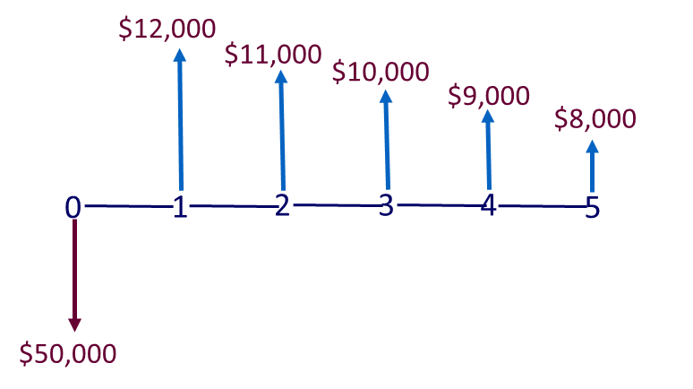

Problem 10 (10 points)
Label each of the following as sunk cost, opportunity cost, or incremental costs: (Chapter 2)
  - You are deciding which car to buy. Car A is $24,000 and car B is $32,000. The difference in price is $8,000. What kind of cost does this represent? Incremental cost

  - Your company invested $300,000 into a study to determine the feasibility of introducing a new product line into the business. The study recommended 2 mutually exclusive feasible alternatives. What kind of cost does the $300K represent? Sunk cost.

  - You have 2 alternatives for a $10,000 investment. Investment A provides a $500 return and investment B provides a $700 return. If you choose Alternative B, what does the $500 return from Alternative A represent? Opportunity cost
Incremental Costs: It is the delta between the outcomes of two mutually exclusive alternatives.
Sunk Costs: A Sunk cost is the money already spent as a part of the decision. Sunk costs must be ignored in engineering decisions because current decisions cannot change the past.
Opportunity Costs: using resources in one activity instead of another.

