BAY AREA

Feds’ Central Valley Project expects to send no water to most California farms this year, little to cities

Kurtis Alexander
Feb. 23, 2022Updated: Feb. 24, 2022 10:05 a.m.
3
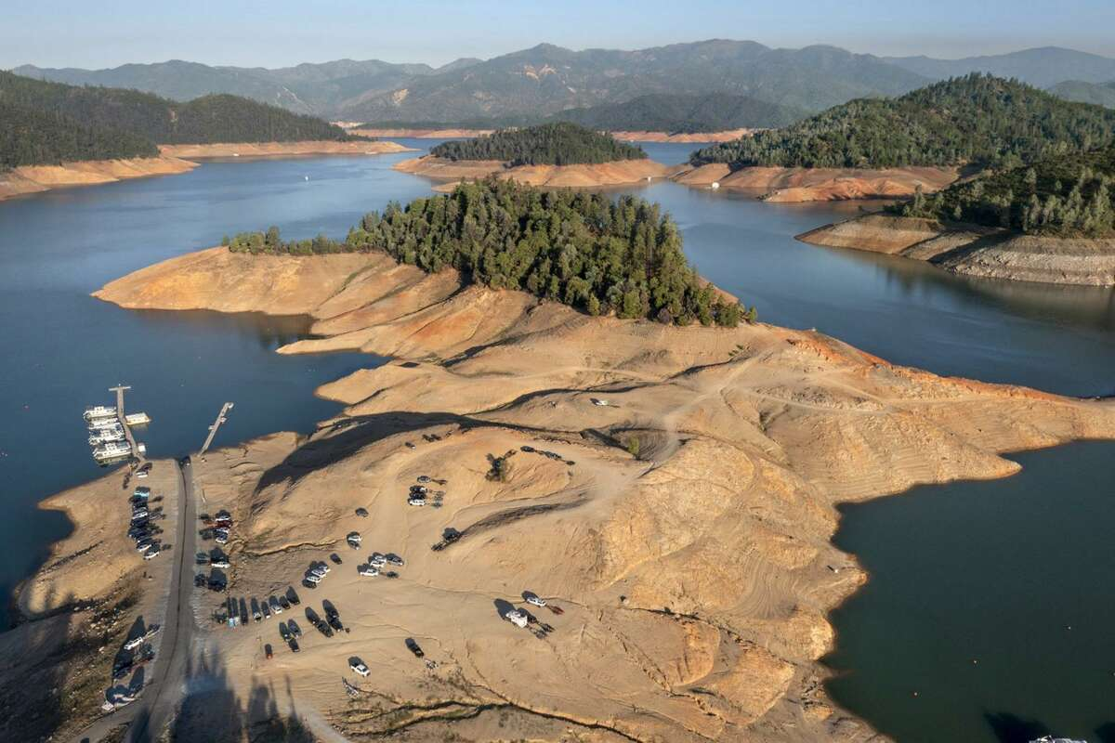1of3
Water levels at Lake Shasta were low as drought conditions persisted last June.
Brian van der Brug/TNS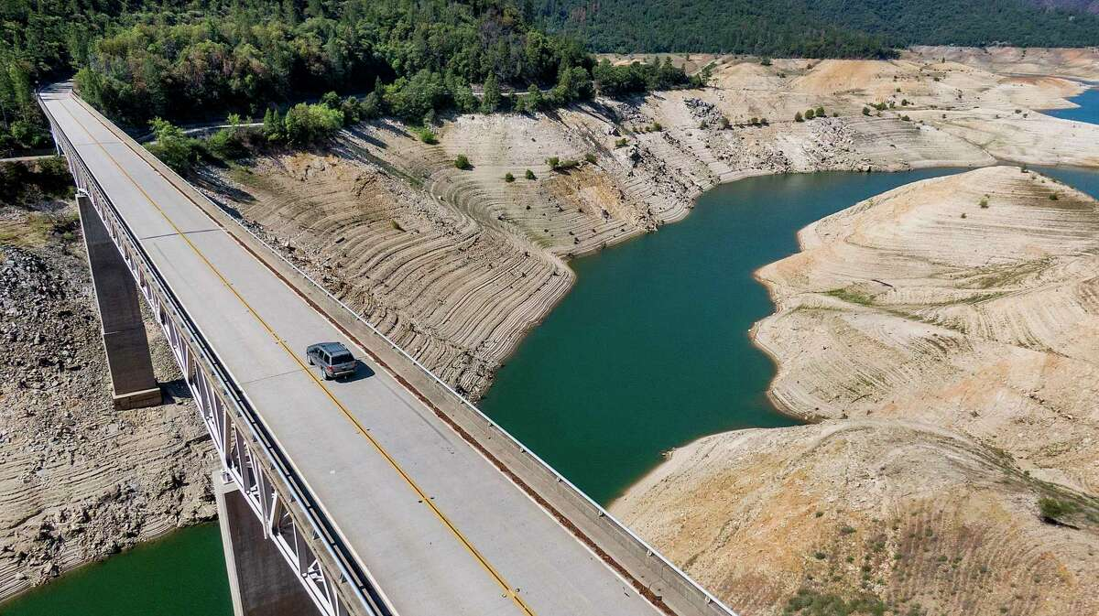
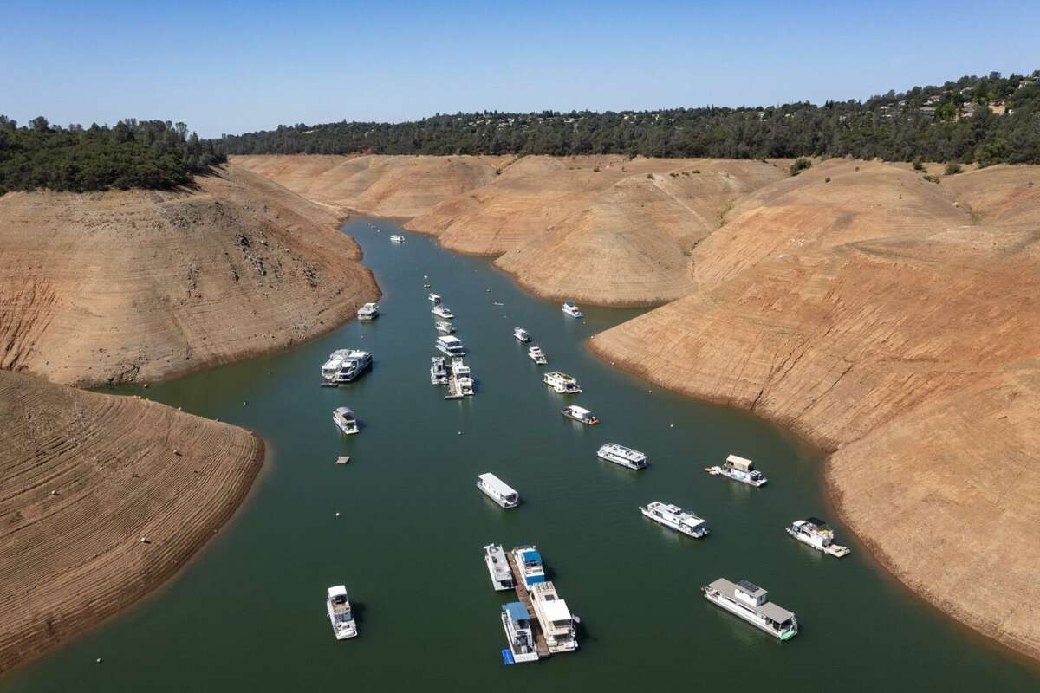

After an extraordinarily dry start to the year, the federal government announced Wednesday that most farms in California will likely receive no water from the state’s biggest reservoirs in 2022, the latest fallout from drought and a blow to an agricultural industry already crippled by tight supplies. Cities and towns, meanwhile, will get just a fraction of the water they requested.
An impending third straight year of drought has left California’s federally managed reservoirs, including giant Shasta and Trinity lakes, soiled by cracked earth and “bathtub rings,” and standing as striking images of the state’s aridity. Many of the storage sites are at near-record lows for this point in the wet winter season, and officials at the Bureau of Reclamation say there’s just not enough water for everyone who needs it.
Most of the recipients of the bureau’s Central Valley Project are irrigation districts, whose farms have made California’s Central Valley the breadbasket of the nation, producing more than half of the nuts, fruits and vegetables in the United States. With no federal water deliveries expected for many of these districts, growers will have to turn to groundwater or storage, if they have it, or else forgo planting and production entirely.
“In terms of tonnage and yield (of crops), I can’t see there not being an impact,” said Chris Scheuring, water attorney for the California Farm Bureau Federation and whose family grows walnuts and almonds.

California drought: State officials plan to deliver more water than the 0% first expected
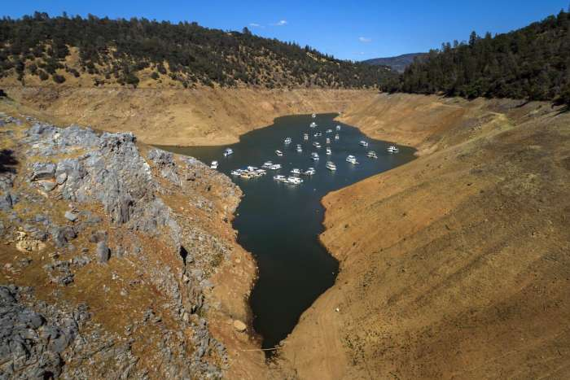

California likely to crack down on water waste with daily $500 fines
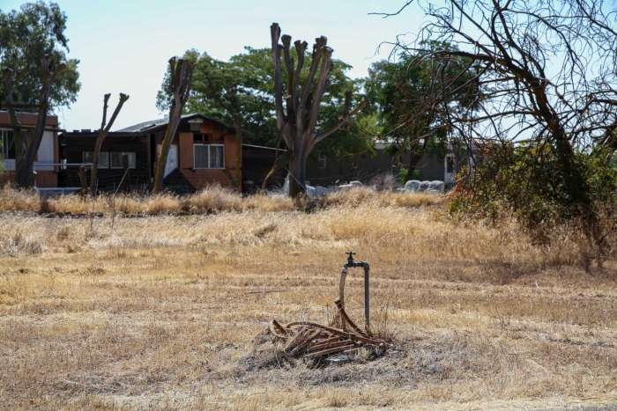

A zero-water allocation would mark the second consecutive year that irrigation districts must cope with no federal water.
“It’s certainly something we’re disappointed to announce,” said Ernest Conant, the Bureau of Reclamation’s regional director, speaking to reporters Wednesday morning about the expected curtailment of water deliveries.
Municipal agencies that receive federal water, which include suppliers in the Bay Area, are projected to get just 25% of what they asked for in 2022. This includes Contra Costa Water District and Santa Clara Valley Water District, which serves the city of San Jose. Last year, most urban customers got about half of what they wanted.
Wednesday’s announcement hits the Santa Clara Valley district especially hard because deliveries from the Central Valley Project typically make up about a quarter of the agency’s water supply. Its local sources, meanwhile, are compromised by the temporary loss of the district’s largest reservoir, Anderson Lake, to accommodate an earthquake retrofitting project.
“We’re really in a tough place here,” said Gary Kremen, chair of the Valley Water governing board, who says he expects many residents in Santa Clara County to face much stricter water restrictions in the coming year.
Already, 15% water restrictions are in place for households and businesses within Valley Water’s service area.
The Central Valley Project, one of the world’s biggest waterworks, operates by capturing runoff between the southern Cascades and the Sierra Nevada in 20 reservoirs and piping it, sometimes hundreds of miles, to more than 250 agencies that contract for the water. The system runs in parallel with the State Water Project, which has forecast that it will meet just 15% of the water requests from contractors.
The projected allocations could change if the water situation changes, but there’s little optimism as California’s wet season is approaching its end, typically in April.
The wet season started strong, with heavy rain and snow in October and December, but the spigot shut off in January. The first two months of the new year have so far marked the driest start to a year in Northern California in at least a century, as measured by the state’s Northern Sierra Eight-Station Index. The grim outset of 2022 follows two years that also won distinction for how dry they were.
And not only are reservoirs low as a result, with Shasta Lake at about 53% of its typical level for this time of year. The snowpack that serves to recharge the reservoirs is low, about 66% of average for the date. Also, there is little precipitation in the forecast.
“Last year was a very bad year, and this year could turn out to be worse,” Conant with the Bureau of Reclamation said.
Not all irrigation districts are projected to receive zero water this year. A few with longtime water rights will get deliveries because of past agreements made with the federal government.
Fishing groups voiced concern Wednesday with the prospect that at least some water will continue flowing to farms when California’s salmon population is on the brink. When water goes to agriculture, there’s less in the rivers to support fish migration.
“At the rate things are going, there’s no doubt that the salmon that try to spawn naturally this summer and fall are likely to fail. Their eggs are likely to die,” said John McManus, president of Golden State Salmon Association.
Kurtis Alexander is a San Francisco Chronicle staff writer. Email: kalexander@sfchronicle.com Twitter: @kurtisalexander

Written By
Kurtis Alexander
Reach Kurtis on

Kurtis Alexander is a general assignment reporter for The San Francisco Chronicle, frequently writing about water, wildfire, climate and the American West. His recent work has focused on the impacts of drought, the widening rural-urban divide and state and federal environmental policy.
Before joining the Chronicle, Alexander worked as a freelance writer and as a staff reporter for several media organizations, including The Fresno Bee and Bay Area News Group, writing about government, politics and the environment.

