German Village at Center of a Fight Over Coal and Climate Is Cleared Out
For years, activists tried to save tiny Lützerath from being razed to make way for the expansion of an open-pit coal mine. This past week, the police moved them out.

An excavator removed protesters’ barricades as part of the clearing of Lützerath, Germany, on Wednesday.Credit...Ingmar Nolting for The New York Times
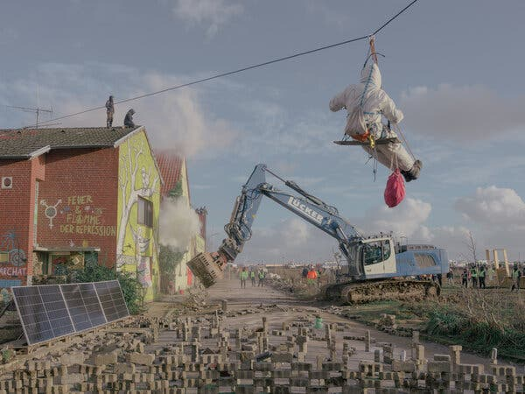
By Christopher F. Schuetze
Christopher was part of the swarm of journalists covering the eviction, but got closer than most. He and the photographer Ingmar Nolting found themselves inside a fortified farmyard when the police stormed the barricades.
Published Jan. 14, 2023Updated Jan. 15, 2023
LÜTZERATH, Germany — The fight for Lützerath was long, but the end, when it finally came, was quick.
In a matter of days this past week, more than 1,000 police officers cleared out the hundreds of climate activists who had sworn to protect the small village, once home to 90 people but no church, which was scheduled to be razed as part of a sprawling open-pit coal mine in western Germany.
The relatively fast demise added to the host of contradictions surrounding Lützerath and how a tiny, now uninhabited, village had taken on an improbable, outsize place in Germany’s debate over how to wean itself off coal.
For years, environmental activists had hoped to forestall the fate of Lützerath — possibly the last of hundreds of villages in Germany to fall to open-pit mining since World War II. For a while, it seemed that the activists would succeed.

But this year the political winds and public sentiment shifted against them. Europe’s energy crisis, ushered in by the war in Ukraine and the end of cheap Russia gas, made coal too hard to quit for now. Even a government that includes the environmentalist-minded Green party turned its back on them.
The activists nonetheless prepared themselves to defend the half dozen houses and farmyards with their bodies. They barricaded themselves in a complex of barns and other structures. They erected and occupied tall watchtowers. They carved out a tunnel network. They nested in the branches of 100-year-old trees.
Image
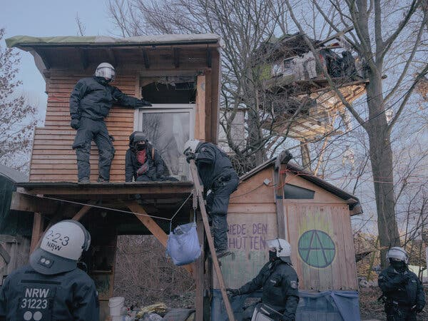
Police officers moving to arrest a protester in the center of the village, which activists had dubbed “Phantasialand,” on Wednesday.Credit...Ingmar Nolting for The New York Times

Image
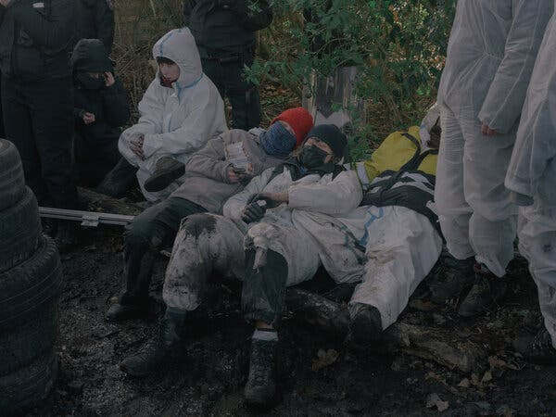
Activists detained by the police on the first day of the eviction.Credit...Ingmar Nolting for The New York Times

But the clearing, which started Wednesday, proved to be less dramatic than some had feared. A few firecrackers were heard, and some stones and bits of food were thrown (it turned out that activists had stockpiled too much). But for the most part, the standoff ended peacefully, almost businesslike. By Friday, the bulk of the activists were gone, some leaving of their own accord, some carried out by police officers, with just a few stragglers left in a few hard-to-reach places.
On Saturday, an estimated 15,000 climate activists, including Greta Thunberg, staged a march in the area, with police using water cannons and nightsticks to prevent protesters from charging the site, even though by then the village was virtually empty and many of its trees already felled. Ms. Thunberg had also visited the village on Friday afternoon.
Climate Forward There’s an ongoing crisis — and tons of news. Our newsletter keeps you up to date. Get it with a Times subscription
Considering that the last farmer moved out of the village months ago, and that courts had reaffirmed the right of the regional power utility to eject the activists, Lützerath’s role as a national symbol was as surprising as the speed with which the village fell.
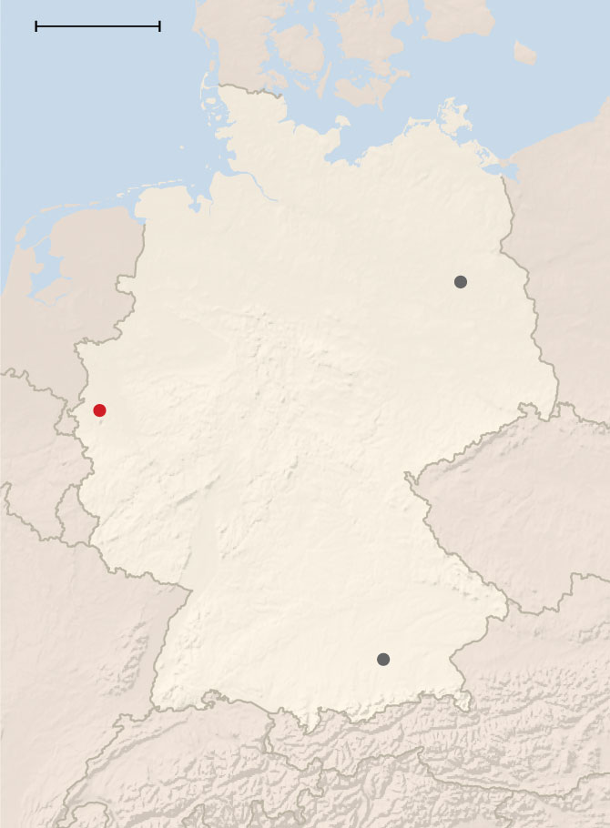
By The New York Times
Lützerath’s fate was sealed last fall, when Robert Habeck, the country’s business, energy and climate minister, and Mona Neubaur, the state minister for the environment and energy, announced a deal to continue mining coal in the region until 2030.
What climate activists and others considered to be the betrayal of Lützerath became a source of controversy for Mr. Habeck, an otherwise popular Green leader whom critics accuse of compromising the party’s environmental principles now that it is in power. He nonetheless defended the decision to extend the use of coal.
“I also believe that climate protection and protest need symbols,” Mr. Habeck said this past week at a news conference in Berlin. “But the empty settlement Lützerath, where no one lives anymore, is in my view the wrong symbol.”

The regional power supplier, RWE, had already bought the land from farmers to expand its mining for brown coal, which the protesters pointed out is an especially polluting fuel.
Image
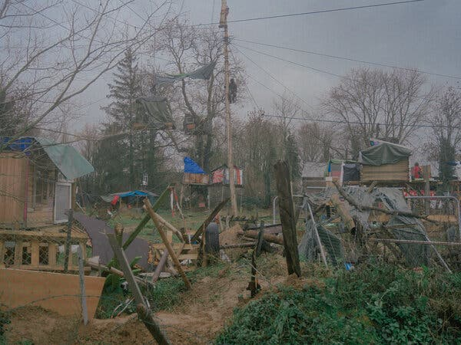
The center of the village before police officers moved in this past week.Credit...Ingmar Nolting for The New York Times

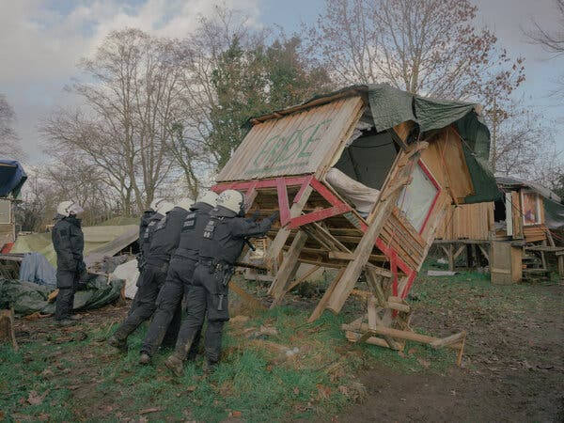
Police officers destroying one of the activists’ structures. Credit...Ingmar Nolting for The New York Times

Moritz Lahaye, 37, would quibble with Mr. Habeck’s assertion that Lützerath was uninhabited. Among the hundreds of activists who had made Lützerath their home, he was acting as its unofficial mayor. At first, he lived in an apartment rented from a farmer, and in the last days he squatted in the neighboring house, where he waited for the police to enter.
“I’m happy to leave here with my head held high, knowing we managed to stay here this long,” Mr. Lahaye said about an hour before armored police officers swarmed the house he was occupying. “We used to count our time here in weeks, and we ended up staying for two and a half years.”
Mr. Lahaye used to support the Greens but now says he does not believe conventional politics can solve the climate crisis.
Franziska Werthmann, 58, who first took part in an environmental protest when she was 16, took a week off work to join the protesters in the village — and had to move the dates forward because the eviction went so quickly.
Even though she believes there are other legitimate avenues of protest, she said Lützerath was an important place to make a stand. “It’s simple,” she said. “If they dig up the coal below this village, Germany will miss its 1.5-degree emission targets,” she said, referring to emissions targets set at the global climate conference in Paris in 2015.
Indeed, there are several conflicting studies on whether the coal underneath Lützerath is actually needed and whether burning it will help push Germany over its emission targets.
Even as he announced the plans to mine the coal under the village, Mr. Habeck asserted that the deal would keep most other coal in the ground and emissions out of the air.
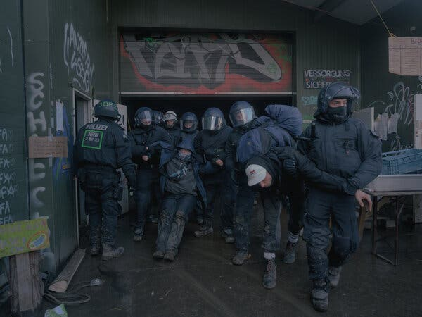
Police officers arresting activists.Credit...Ingmar Nolting for The New York Times

Image
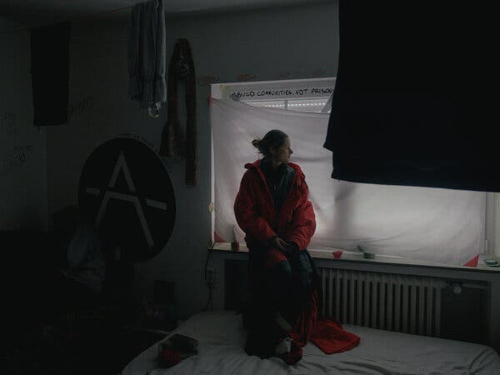
Saskia Meyer, in the room where she was squatting, on Thursday, the second day of the eviction.Credit...Ingmar Nolting for The New York Times

If not for the renewed demand for coal as Germany turned away from cheap Russian gas this year, the pressure to halt coal mining might have been more significant.
“If it wasn’t for the war, we would have found a political solution to save the village,” said Kathrin Henneberger, a lawmaker in Parliament and Green party member who spent days as a parliamentary observer on the site.
Ms. Henneberger was an activist before entering politics in Berlin, where she tried to persuade her party to vote for a moratorium on the pit mine expansion, even after Mr. Habeck announced the deal that sealed Lützerath’s fate.
But she said, “Mining law doesn’t recognize the climate crisis — mining law just says the market must be supplied with raw materials.”
Once politics failed to save Lützerath, the police action became inevitable. Early this past week, security forces sealed off the village with a fence. An access ramp was built into the pit mine, allowing additional parking for the hundreds of police vans that brought in more than 1,000 officers, as well as water cannons and armored bulldozers from states around the country.
Starting Tuesday, the police cleared the access road to the village of activists, some on ground and others dangling from 9-foot-tall tripods. Then, starting Wednesday, they entered the village proper, and by Thursday they had cleared the two major farmyards and a complex of barns in which protesters had barricaded themselves. By Friday, the standoff, and Lützrath, were all but finished.
“Even if the village is gone,” said Saskia Meyer, 36, a nutritionist who spent months commuting between Lützrath and Berlin, “it will live on in our hearts.”
Image
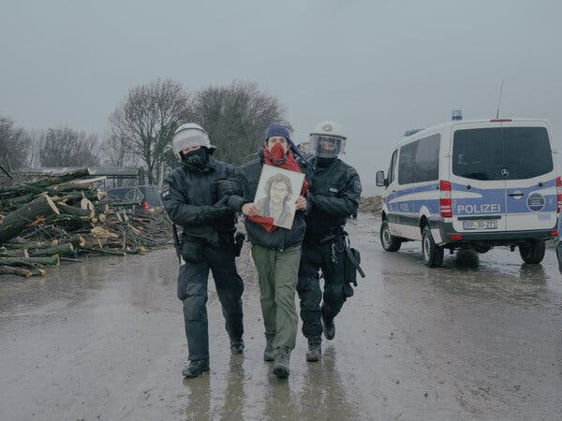
Police officers escorting away an activist on Thursday.Credit...Ingmar Nolting for The New York Times

Germany and Coal

Germany will fire up coal plants again in an effort to save natural gas.
June 19, 2022

Why ‘Green’ Germany Remains Addicted to Coal
Oct. 10, 2018

Christopher F. Schuetze covers German news, society and occasionally arts from the Berlin bureau. Before moving to Germany, he lived in the Netherlands, where he covered everything from tulips to sea-level rise. @CFSchuetze

