Business Models

How to Design a Winning Business Model
by
- Ramon Casadesus-Masanell
and
- Joan E. Ricart
From the Magazine (January–February 2011)
Summary. Reprint: R1101G Most executives believe that competing through business models is critical for success, but few have come to grips with how best to do so. One common mistake, the authors’ studies show, is enterprises’ unwavering focus on creating innovative...more

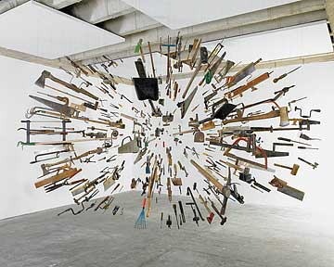
Artwork: Damián Ortega, Controller of the Universe, 2007, found tools and wire, 285 x 405 x 455 cm
Strategy has been the primary building block of competitiveness over the past three decades, but in the future, the quest for sustainable advantage may well begin with the business model. While the convergence of information and communication technologies in the 1990s resulted in a short-lived fascination with business models, forces such as deregulation, technological change, globalization, and sustainability have rekindled interest in the concept today. Since 2006, the IBM Institute for Business Value’s biannual Global CEO Study has reported that senior executives across industries regard developing innovative business models as a major priority. A 2009 follow-up study reveals that seven out of 10 companies are engaging in business-model innovation, and an incredible 98% are modifying their business models to some extent. Business model innovation is undoubtedly here to stay.
That isn’t surprising. The pressure to crack open markets in developing countries, particularly those at the middle and bottom of the pyramid, is driving a surge in business-model innovation. The economic slowdown in the developed world is forcing companies to modify their business models or create new ones. In addition, the rise of new technology-based and low-cost rivals is threatening incumbents, reshaping industries, and redistributing profits. Indeed, the ways by which companies create and capture value through their business models is undergoing a radical transformation worldwide.
Yet most enterprises haven’t fully come to grips with how to compete through business models. Our studies over the past seven years show that much of the problem lies in companies’ unwavering focus on creating innovative models and evaluating their efficacy in isolation—just as engineers test new technologies or products. However, the success or failure of a company’s business model depends largely on how it interacts with models of other players in the industry. (Almost any business model will perform brilliantly if a company is lucky enough to be the only one in a market.) Because companies build them without thinking about the competition, they routinely deploy doomed business models.

Business Model
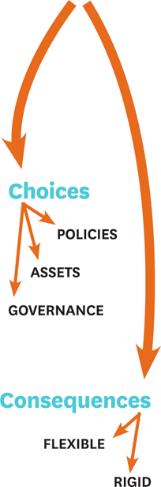
A business model comprises choices and consequences. ...
Our research also shows that when enterprises compete using business models that differ from one another, the outcomes are difficult to predict. One business model may appear superior to others when analyzed in isolation but create less value than the others when interactions are considered. Or rivals may end up becoming partners in value creation. Appraising models in a stand-alone fashion leads to faulty assessments of their strengths and weaknesses and bad decision making. This is a big reason why so many new business models fail.
Moreover, the propensity to ignore the dynamic elements of business models results in many companies failing to use them to their full potential. Few executives realize that they can design business models to generate winner-take-all effects that resemble the network externalities that high-tech companies such as Microsoft, eBay, and Facebook have created. Whereas network effects are an exogenous feature of technologies, winner-take-all effects can be triggered by companies if they make the right choices in developing their business models. Good business models create virtuous cycles that, over time, result in competitive advantage. Smart companies know how to strengthen their virtuous cycles, weaken those of rivals, and even use their virtuous cycles to turn competitors’ strengths into weaknesses.
“Isn’t that strategy?” we’re often asked. It isn’t—and unless managers learn to understand the distinct realms of business models, strategy, and tactics, while taking into account how they interact, they will never find the most effective ways to compete.

What Is a Business Model, Really?
Everyone agrees that executives must know how business models work if their organizations are to thrive, yet there continues to be little agreement on an operating definition. Management writer Joan Magretta defined a business model as “the story that explains how an enterprise works,” harking back to Peter Drucker, who described it as the answer to the questions: Who is your customer, what does the customer value, and how do you deliver value at an appropriate cost?
Other experts define a business model by specifying the main characteristics of a good one. For example, Harvard Business School’s Clay Christensen suggests that a business model should consist of four elements: a customer value proposition, a profit formula, key resources, and key processes. Such descriptions undoubtedly help executives evaluate business models, but they impose preconceptions about what they should look like and may constrain the development of radically different ones.
Our studies suggest that one component of a business model must be the choices that executives make about how the organization should operate—choices such as compensation practices, procurement contracts, location of facilities, extent of vertical integration, sales and marketing initiatives, and so on. Managerial choices, of course, have consequences. For instance, pricing (a choice) affects sales volume, which, in turn, shapes the company’s scale economies and bargaining power (both consequences). These consequences influence the company’s logic of value creation and value capture, so they too must have a place in the definition. In its simplest conceptualization, therefore, a business model consists of a set of managerial choices and the consequences of those choices.
Companies make three types of choices when creating business models. Policy choices determine the actions an organization takes across all its operations (such as using nonunion workers, locating plants in rural areas, or encouraging employees to fly coach class). Asset choices pertain to the tangible resources a company deploys (manufacturing facilities or satellite communication systems, for instance). And governance choices refer to how a company arranges decision-making rights over the other two (should we own or lease machinery?). Seemingly innocuous differences in the governance of policies and assets influence their effectiveness a great deal.
Consequences can be either flexible or rigid. A flexible consequence is one that responds quickly when the underlying choice changes. For example, choosing to increase prices will immediately result in lower volumes. By contrast, a company’s culture of frugality—built over time through policies that oblige employees to fly economy class, share hotel rooms, and work out of Spartan offices—is unlikely to disappear immediately even when those choices change, making it a rigid consequence. These distinctions are important because they affect competitiveness. Unlike flexible consequences, rigid ones are difficult to imitate because companies need time to build them.
Take, for instance, Ryanair, which switched in the early 1990s from a traditional business model to a low-cost one. The Irish airline eliminated all frills, cut costs, and slashed prices to unheard-of levels. The choices the company made included offering low fares, flying out of only secondary airports, catering to only one class of passenger, charging for all additional services, serving no meals, making only short-haul flights, and utilizing a standardized fleet of Boeing 737s. It also chose to use a nonunionized workforce, offer high-powered incentives to employees, operate out of a lean headquarters, and so on. The consequences of those choices were high volumes, low variable and fixed costs, a reputation for reasonable fares, and an aggressive management team, to name a few. (See “Ryanair’s Business Model Then and Now.”) The result is a business model that enables Ryanair to offer a decent level of service at a low cost without radically lowering customers’ willingness to pay for its tickets.

Ryanair’s Business Model Then and Now
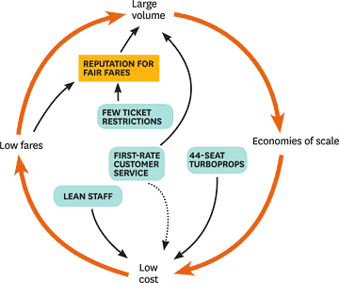
Then This depiction of Ryanair’s business model in the 1980s highlights the airline’s major choices at the ...

How Business Models Generate Virtuous Cycles
Not all business models work equally well, of course. Good ones share certain characteristics: They align with the company’s goals, are self-reinforcing, and are robust. (See the sidebar “Three Characteristics of a Good Business Model.”) Above all, successful business models generate virtuous cycles, or feedback loops, that are self-reinforcing. This is the most powerful and neglected aspect of business models.

Three Characteristics of a Good Business Model
How can you tell if a business model will be effective? A good one will meet three criteria. 1. Is it aligned with company goals? ...
Our studies show that the competitive advantage of high-tech companies such as Apple, Microsoft, and Intel stems largely from their accumulated assets—an installed base of iPods, Xboxes, or PCs, for instance. The leaders gathered those assets not by buying them but by making smart choices about pricing, royalties, product range, and so on. In other words, they’re consequences of business model choices. Any enterprise can make choices that allow it to build assets or resources—be they project management skills, production experience, reputation, asset utilization, trust, or bargaining power—that make a difference in its sector.
The consequences enable further choices, and so on. This process generates virtuous cycles that continuously strengthen the business model, creating a dynamic that’s similar to that of network effects. As the cycles spin, stocks of the company’s key assets (or resources) grow, enhancing the enterprise’s competitive advantage. Smart companies design business models to trigger virtuous cycles that, over time, expand both value creation and capture.
For example, Ryanair’s business model creates several virtuous cycles that maximize its profits through increasingly low costs and prices. (See the exhibit “Ryanair’s Key Virtuous Cycles.”) All of the cycles result in reduced costs, which allow for lower prices that grow sales and ultimately lead to increased profits. Its competitive advantage keeps growing as long as the virtuous cycles generated by its business model spin. Just as a fast-moving body is hard to stop because of kinetic energy, it’s tough to halt well-functioning virtuous cycles.

Ryanair’s Key Virtuous Cycles
Cycle 1: Low fares >> High volumes >> Greater bargaining power with suppliers >> Lower fixed costs >> Even lower fares ...
However, they don’t go on forever. They usually reach a limit and trigger counterbalancing cycles, or they slow down because of their interactions with other business models. In fact, when interrupted, the synergies work in the opposite direction and erode competitive advantage. For example, one of Ryanair’s cycles could become vicious if its employees unionized and demanded higher wages, and the airline could no longer offer the lowest fares. It would then lose volume, and aircraft utilization would fall. Since Ryanair’s investment in its fleet assumes a very high rate of utilization, this change would have a magnified effect on profitability.
It’s easy to see that virtuous cycles can be created by a low-cost, no-frills player, but a differentiator may also create virtuous cycles. Take the case of Irizar, a Spanish manufacturer of bodies for luxury motor coaches, which posted large losses after a series of ill-conceived moves in the 1980s. Irizar’s leadership changed twice in 1990 and morale hit an all-time low, prompting the new head of the company’s steering team, Koldo Saratxaga, to make major changes. He transformed the organization’s business model by making choices that yielded three rigid consequences: employees’ tremendous sense of ownership, feelings of accomplishment, and trust. The choices included eliminating hierarchy, decentralizing decision making, focusing on teams to get work done, and having workers own the assets. (See the exhibit “Irizar’s Novel Business Model.”)

Irizar’s Novel Business Model
When Irizar—a Spanish cooperative that manufactures luxury motor coach bodies—created a radically different ...
Irizar’s main objective, as a cooperative, is to increase the number of well-paying jobs in the Basque Country, so the company developed a business model that generates a great deal of customer value. Its key virtuous cycle connects customers’ willingness to pay with relatively low cost, generating high profits that feed innovation, service, and high quality. In fact, quality is the cornerstone of Irizar’s culture. Focusing on customer loyalty and an empowered workforce, the company enjoyed a 23.9% compound annual growth rate over the 14 years that Saratxaga was CEO. Producing 4,000 coaches in 2010 and generating revenues of about €400 million, Irizar is an example of a radically different business model that generates virtuous cycles.

Competing with Business Models
It’s easy to infuse virtuousness in cycles when there are no competitors, but few business models operate in vacuums—at least, not for long. To compete with rivals that have similar business models, companies must quickly build rigid consequences so that they can create and capture more value than rivals do. It’s a different story when enterprises compete against dissimilar business models; the results are often unpredictable, and it’s tough to know which business model will perform well.
Take, for instance, the battle between two of Finland’s dominant retailers: S Group, a consumers’ cooperative, and Kesko, which uses entrepreneur-retailers to own and operate its stores. We’ve tracked the firms for over a decade, and Kesko’s business model appears to be superior: The incentives it offers franchisees should result in rapid growth and high profits. However, it turns out that the S Group’s business model hurts Kesko more than Kesko’s affects the S Group. Since customers own the S Group, the retailer often reduces prices and increases customer bonuses, which allows it to gain market share from Kesko. That forces Kesko to lower its prices and its profits fall, demotivating its entrepreneur-retailers. As a result, Kesko underperforms the S Group. Over time, the S Group’s opaque corporate governance system allows slack to creep into the system, and it is forced to hike prices. This allows Kesko to also increase prices and improve profitability, drive its entrepreneur-retailers, and win back more customers through its superior shopping experience. That sparks another cycle of rivalry.
Companies can compete through business models in three ways: They can strengthen their own virtuous cycles, block or destroy the cycles of rivals, or build complementarities with rivals’ cycles, which results in substitutes mutating into complements.

Strengthen your virtuous cycle.
Companies can modify their business models to generate new virtuous cycles that enable them to compete more effectively with rivals. These cycles often have consequences that strengthen cycles elsewhere in the business model. Until recently, Boeing and Airbus competed using essentially the same virtuous cycles. Airbus matched Boeing’s offerings in every segment, the exception being the very large commercial transport segment where Boeing had launched the 747 in 1969. Given the lumpiness of demand for aircraft, their big-ticket nature, and cyclicality, price competition has been intense.

How Airbus Bolstered Its Business Model
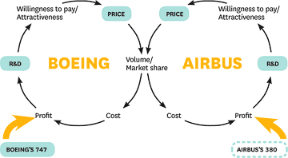
Companies can often strengthen their business models to take on competitors more effectively. Airbus’s ...
Historically, Boeing held the upper hand because its 747 enjoyed a monopoly, and it could reinvest those profits to strengthen its position in other segments. Analysts estimate that the 747 contributed 70 cents to every dollar of Boeing’s profits by the early 1990s. Since R&D investment is the most important driver of customers’ willingness to pay, Airbus was at a disadvantage. It stayed afloat by obtaining low-interest loans from European governments. Without the subsidies, Airbus’s cycle would have become vicious.
With the subsidies likely to dry up, Airbus modified its business model by developing a very large commercial transport, the 380. To dissuade Airbus, Boeing announced a stretch version of the 747. However, that aircraft would cut into the 747’s profits, so it seems unlikely that Boeing will ever launch it. Not only does the 380 help maintain the virtuousness of Airbus’s cycle in small and midsize planes, but also it helps decelerate the virtuousness of Boeing’s cycle. The increase in rivalry suggests that the 747 will become less of a money-spinner for Boeing. That’s why it is trying to strengthen its position in midsize aircraft, where competition is likely to become even tougher when sales of the 380 take off, by developing the 787.

Weaken competitors’ cycles.
Some companies get ahead by using the rigid consequences of their choices to weaken new entrants’ virtuous cycles. Whether a new technology disrupts an industry or not depends not only on the intrinsic benefits of that technology but also on interactions with other players. Consider, for instance, the battle between Microsoft and Linux, which feeds its virtuous cycle by being free of charge and allowing users to contribute code improvements. Unlike Airbus, Microsoft has focused on weakening its competitor’s virtuous cycle. It uses its relationship with OEMs to have Windows preinstalled on PCs and laptops so that it can prevent Linux from growing its customer base. It discourages people from taking advantage of Linux’s free operating system and applications by spreading fear, uncertainty, and doubt about the products.
In the future, Microsoft could raise Windows’ value by learning more from users and offering special prices to increase sales in the education sector, or decrease Linux’s value by undercutting purchases by strategic buyers and preventing Windows applications from running on Linux. Linux’s value creation potential may theoretically be greater than that of Windows, but its installed base will never eclipse that of Microsoft as long as the software giant succeeds in disrupting its key virtuous cycles.

Turn competitors into complements.
Rivals with different business models can also become partners in value creation. In 1999, Betfair, an online betting exchange, took on British bookmakers such as Ladbrokes and William Hill by enabling people to anonymously place bets against one another. Unlike traditional bookmakers who only offer odds, Betfair is a two-sided internet-based platform that allows customers to both place bets and offer odds to others. One-sided and two-sided businesses have different virtuous cycles: While bookmakers create value by managing risk and capture it through the odds they offer, betting exchanges themselves bear no risk. They create value by matching the two sides of the market and capture it by taking a cut of the net winnings.
Over the past decade, Ladbrokes’ and William Hill’s gross winnings have declined, so Betfair has hurt them, but not as much as expected. Because Betfair has improved odds in general, gamblers lose less money. They then place more wagers, and when bookies pay out, bettors gamble again, feeding a virtuous cycle. This has expanded the British gambling market by a larger proportion than just the improvement of odds might suggest. The better odds Betfair offers also help traditional bookmakers gauge market sentiment more accurately and hedge their exposures at a lower cost. When a new business model creates complementarities between competitors, it is less likely that incumbents will respond aggressively. The initial reaction from bookmakers to Betfair was hostile, but they have become more accommodating of its presence ever since.

Business Models vs. Strategy vs. Tactics
No three concepts are of as much use to managers or as misunderstood as strategy, business models, and tactics. Many use the terms synonymously, which can lead to poor decision making.
To be sure, the three are interrelated. Whereas business models refer to the logic of the company—how it operates and creates and captures value for stakeholders in a competitive marketplace—strategy is the plan to create a unique and valuable position involving a distinctive set of activities. That definition implies that the enterprise has made a choice about how it wishes to compete in the marketplace. The system of choices and consequences is a reflection of the strategy, but it isn’t the strategy; it’s the business model. Strategy refers to the contingent plan about which business model to use. The key word is contingent; strategies contain provisions against a range of contingencies (such as competitors’ moves or environmental shocks), whether or not they take place. While every organization has a business model, not every organization has a strategy—a plan of action for contingencies that may arise.
Consider Ryanair. The airline was on the brink of bankruptcy in the 1990s, and the strategy it chose to reinvent itself was to become the Southwest Airlines of Europe. The new logic of the organization—its way of creating and capturing value for stakeholders—was Ryanair’s new business model.
Changing strategic choices can be expensive, but enterprises still have a range of options to compete that are comparatively easy and inexpensive to deploy. These are tactics—the residual choices open to a company by virtue of the business model that it employs. Business models determine the tactics available to compete in the marketplace. For instance, Metro, the world’s largest newspaper, has created an ad-sponsored business model that dictates that the product must be free. That precludes Metro from using price as a tactic.
Think of a business model as if it were an automobile. Different car designs function differently—conventional engines operate quite differently from hybrids, and standard transmissions from automatics—and create different value for drivers. The way the automobile is built places constraints on what the driver can do; it determines which tactics the driver can use. A low-powered compact would create more value for the driver who wants to maneuver through the narrow streets of Barcelona’s Gothic Quarter than would a large SUV, in which the task would be impossible. Imagine that the driver could modify the features of the car: shape, power, fuel consumption, seats. Such modifications would not be tactical; they would constitute strategies because they would entail changing the machine (the “business model”) itself. In sum, strategy is designing and building the car, the business model is the car, and tactics are how you drive the car.
Strategy focuses on building competitive advantage by defending a unique position or exploiting a valuable and idiosyncratic set of resources. Those positions and resources are created by virtuous cycles, so executives should develop business models that activate those cycles. That’s tough, especially because of their interactions with those of other players such as competitors, complementors, customers, and suppliers that are all fighting to create and capture value too. That’s the essence of competitiveness—and developing strategy, tactics, or innovative business models has never been easy.
A version of this article appeared in the January–February 2011 issue of Harvard Business Review.
- 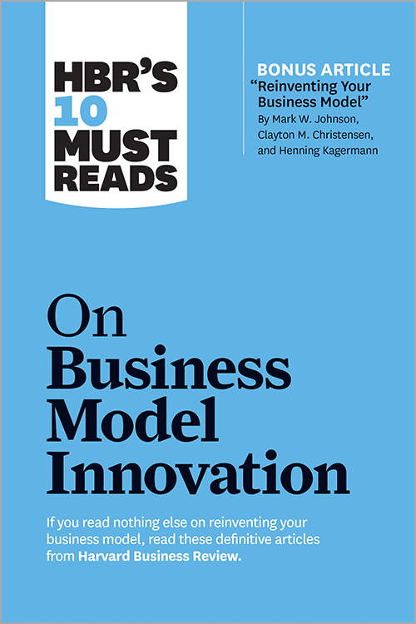

HBR's 10 Must Reads on Business Model Innovation (with featured article "Reinventing Your Business Model" by Mark W. Johnson, Clayton M. Christensen, and Henning Kagermann)
- 