CSUSM
BUS 322
Introduction to Data Analytics
Spring 2022
as of
1/24/22

Hybrid Modality

Professor: Derek D. Podobas

Phone: (949) 842-6632 (text)

E-mail: dpodobas@csusm.edu or derek.podobas@cox.net

Zoom Class Meetings:

- BUS 322-07 W: 4:30 PM - 6:20 PM Mark. 305 and Zoom
Zoom Link: https://csusm.zoom.us/j/82716877145

Virtual Office Hours: via text: (949)-842-6632 or by appt.

Your professor reserves the right to make ongoing adjustments/changes.
to any part of this syllabus and/or class throughout the semester.

COBA Mission and Vision

Mission: We are committed to providing rigorous and relevant educational programs using a balance of theoretical, experiential, and applied learning to educate a diverse body of students to become responsible, engaged citizens with a global mindset who contribute positively to their communities and organizations. We achieve this through collaborative relationships among faculty, staff, students, and the community guided by faculty involved in a combination of academic scholarship, applied scholarship, and professional experience.

Vision: CoBA aspires to be recognized as an engine for innovation and excellence in business education and research through collaboration with stakeholders to advance the economic vitality of the region.

Course Description
Studies the use of statistical data in order to understand and solve business problems. Reviews descriptive statistics tools and inferential statistics topics including estimation, hypothesis testing, simple and multiple regression analysis, and optimization techniques.
Enrollment restricted to students who have completed all lower-division pre-business core (major status in Business Administration, i.e., attained business status).

Students will use Microsoft Excel as a graphical, computing, and analytical tool.

Course Material:

Business Statistics: A Decision-Making Approach 10e, Groebner, Shannon, Fry, and Smith.

Camm: Essentials of Business Analytics, 2e, Centage,

Additional material will be provided by the instructor.

Course Learning Outcomes:

Upon successful completion of this course, each student will be able to master the following areas of knowledge:

- Use of Excel in Data Analytics
- Descriptive Statistics and Data Mining
- Modeling Uncertainty
- Predictive Analytics
- Statistical Inference
- Decision Analysis
- Optimization Techniques

Undergraduate Student Learning Outcomes
1. Communication:
1a. Our graduates will be able to communicate effectively and professionally in oral form.
1b. Our graduates will be able to communicate effectively and professionally in written form.
2. Critical Thinking and Problem Solving: Our graduates will be able to demonstrate critical thinking and problem-solving skills.
3. Interpersonal and Collaboration: Our graduates will be able to demonstrate interpersonal and collaboration skills.
4. Analytics: Our graduates will be able to apply analytics to business situations.
5. Information Technology: Our graduates will be able to demonstrate proficiency in the use of technological tools.
6. Ethics and Social Responsibility: Our graduates will be able to apply ethical and socially responsible perspectives/viewpoints and demonstrate an understanding of their consequences.
7. Global: Our graduates will be able to identify and apply global perspectives in making business decisions.
8. General Business: Our graduates will be able to describe and apply foundational business concepts, theories, processes, and strategies.

Student competencies will be measured by:

- Quizzes (15%) – Three quizzes-each quiz is worth 5%.
An optional quiz 4 may be offered before the final exam.

- Exams (85%) – There will be four exams over the course of the semester.

Exam 1 = 15%, Exam 2 = 20%, Exam 3 = 25%, Exam 4 = 25%

Grading Scale (in %):

A | 100.00 - 95.00 | B- | 82.99 - 80.00 | D+ | 69.99 - 67.00
A- | 94.99 - 90.00 | C+ | 79.99 - 77.00 | D | 66.99 - 63.00
B+ | 89.99 - 87.00 | C | 76.99 - 73.00 | D- | 62.99 - 60.00
B | 86.99- 83.00 | C- | 72.99 - 70.00 | F | Below 60%
 |  |  |  | CR
 |  |  |  | NC

Your final grade is a function of the total number of points you have earned through-out the entire semester. A class curve will be applied to determine final grades. Your individual class standing is shown on the Gradecheck spreadsheet.

Computing Software Required:

Windows PC or Equivalent; Microsoft Office for Windows software is required. If you have a Mac computer or a tablet, please make sure that it is compatible with the software and hardware used in this class.

Note: assume that technology will fail at some point when it comes to computers and printers. Plan. Do not leave completion/submission of assignments or projects for the last possible moment.

Study Time Expectations:
This class will require between 3 to 4 hours of your study time every week. Please make certain that you can meet this requirement.

Zoom Session Attendance:

Class attendance: waived

University Policies

Class Behavior Expectations:

- Students in this class are expected to follow these basic principles:
  - Demonstrate respect for oneself and for others.
  - Treat others with dignity.
  - Behave in a way which promotes a physically and psychologically safe, secure, and supportive climate.
  - Allow all community members to engage as full and active participants where the free flow of ideas is encouraged and affirmed.

Credit Hour Policy:

Please note that per the University Credit Hour Policy students are expected to spend a minimum of two hours outside of the classroom each week for each unit of credit engaged in learning. For this course, it means that you are expected to spend the required minimum number of hours each week working on readings, assignments, and preparation for class, project work, etc.

Inclusivity Statement:

Our community represents a rich variety of backgrounds, experiences, demographics and perspectives and we are committed to fostering a learning environment where every individual is respected and engaged. To facilitate a dynamic and inclusive educational experience, we ask all members of the community to:

- be open to the perspectives of others.
- appreciate the uniqueness their colleagues.
- take advantage of the opportunity to learn from each other.
- exchange experiences, values, and beliefs.
- communicate in a respectful manner.
- be aware of individuals who are marginalized and involve them.
- keep confidential discussions private.

Academic Honesty

Students are expected to adhere to standards of academic honesty and integrity, as outlined in the Student Academic Honesty Policy. All assignments must be original work, clearly expressed and as free from errors as possible. All ideas/materials that are borrowed from other sources must have appropriate references to the original sources. Any quoted material should give credit to the source and be punctuated with quotation marks. The University’s Academic Honesty Policy states, “The maintenance of academic integrity and quality education is the responsibility of each student within CSUSM and the CSU system. Cheating and plagiarism in connection with an academic program at a campus is listed as an offense for which a student may be expelled, suspended, put on probation, or given a less severe disciplinary sanction.” The instructor is required to report all instances or possible academic dishonesty to the Dean of Students. Please see the online version for more details at:

https://www.csusm.edu/dos/about/polpro.html

Learning Accommodations

Students requiring reasonable accommodations because of a disability must be approved for services by providing appropriate and recent documentations to the Office of Disability Support Services (DSS). Students authorized by DSS to receive reasonable accommodations should meet with me during my office hours in order to ensure confidentiality.

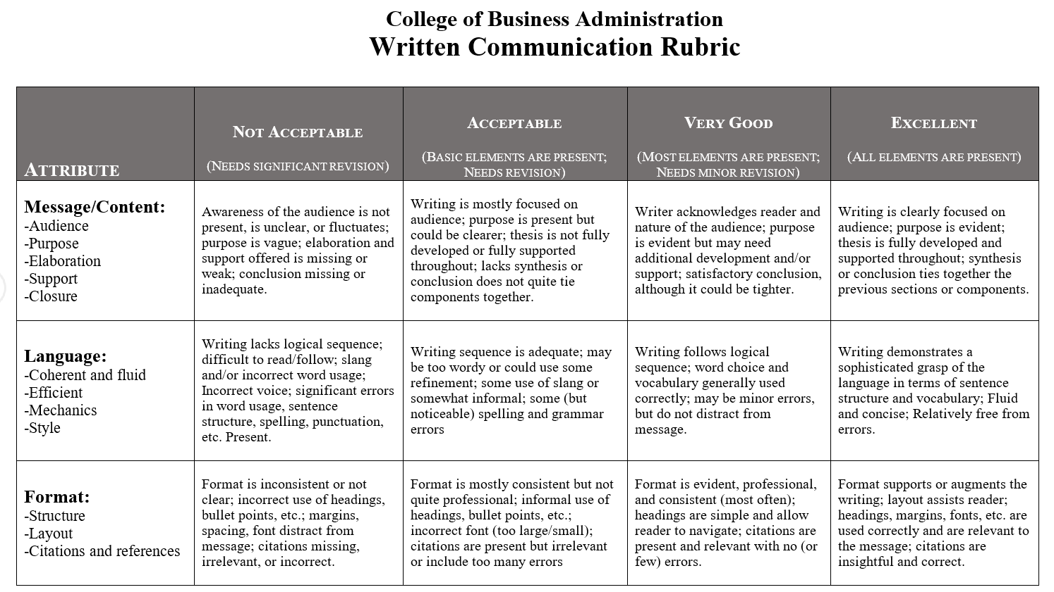

Attributes and Definitions
Message/Content
- Audience: It is clear that the writer understands and addresses the audience. This is shown by how the reader is engaged, the words chosen, etc. For example, a message written for a general audience will avoid discipline-specific jargon.
- Purpose: All writing has a purpose/goal; the reader should be able to identify what the writer’s purpose/goal is.
- Elaboration: The message is fully developed and remains focused on the topic throughout. The writer uses compelling content to convey the writer’s perspective.
- Support: Examples, illustrations, and sources are used to clarify and persuade. The supporting information should be relevant, credible, and clearly related to the message and its subcomponents.
- Closure: The writing provides some form of synthesis or a conclusion that ties together the previous sections or components of the message.

Language
- Coherent and Fluid: Main ideas and meaning are easy to read, follow, and understand. Writing connects ideas in a fluid and comprehensible way. Writing uses language/vocabulary accurately and is understandable by the intended audience.
- Efficient: Writing is concise and to-the-point.
- Style: Writer uses appropriate voice (active or passive) and point of view (first, second, third person).
- Mechanics: Grammar, spelling, punctuation, and capitalization abide by conventions of standard written English. Numbers (using words and numerals to represent numbers) abide by conventions of business writing.

Format
- Formatting is professional, consistent, and easy to navigate.
- Margins, line spacing, and font selection and format are appropriate for the type of writing.
- The following apply as needed:
- Headings are effectively used to help the reader navigate the document; they introduce and describe ideas contained in sections.
- Bullet points and numbered lists are appropriately used to organize and present key ideas.
- Cover page, table of contents, and page numbers abide by conventions of business writing.
- Illustrations are appropriately formatted, numbered, and titled.
- Citations and references abide by conventions of an accepted formatting guide (e.g., APA, MLA, Chicago).
- Citation help: http://www.citationmachine.net

