The P-value Notes
Consider an experiment in which one group of subjects receive a placebo, and another receives an experimental drug.
After compiling the results, how will we know if that difference in means (if any) between the placebo group and the actual drug taking group indicates that the drug works and is not just a result of chance?
The most common way to approach this problem is to use statistical hypothesis testing.
First, we state the null hypothesis (Ho) of “no statistical difference between the groups” and the alternative hypothesis of “a statistical difference between the groups”.
Traditionally, the cut-off value (critical value) to reject the null hypothesis is 0.05 (in one tailed distribution) and 2.5% in a two-tailed solution.
Once we calculate the critical value, we calculate the p-value (test statistic). The p-value is a probability.
We can conclude that if the p-value is greater than the critical value, the difference in sample means is statistically significant at the 5% significance level. That is, we can state that the difference between means provides a sufficient evidence to reject the “no difference in population means” hypothesis.
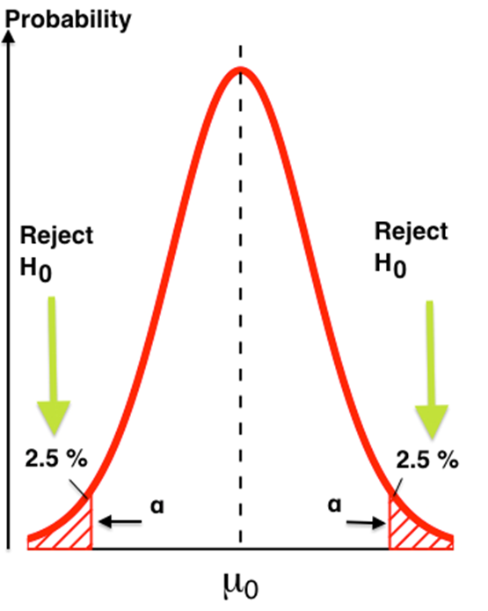

p-values

MISCONCEPTIONS ABOUT THE P VALUE

Clinical versus statistical significance of the effect size
There is a misconception that a very small p value means the difference between groups is highly relevant. Looking at the p value alone has no clinical relevance.

Nonsignificant p values
Another misconception is that if the p value is greater than 5%, the new treatment has no effect. The p value indicates the probability of observing a difference as large or larger than what was observed, under the null hypothesis. But if the new treatment has an effect of smaller size, a study with a small sample may be underpowered to detect it.

Overinterpreting a nonsignificant p value that is close to 5%
Yet another misconception is that if the p value is close to 5%, there is a trend towards a group difference. It is inappropriate to interpret a p value of, say, 0.06, as a trend towards a difference.
A p value of 0.06 means that there is a probability of 6% of obtaining that result by chance when the treatment has no real effect. Because we set the significance level at 5%, the null hypothesis should not be rejected.

Effect sizes versus p values
Many researchers believe that the p value is the most important number to report. However, we should focus on the effect size.
Avoid reporting the p value alone and preferably report the mean values for each group, the difference, and the 95% confidence interval-then the p value.

