Is Boeing 787 really Dreamliner?

What is 787 Dreamliner?
Boeing 787 Dreamliner (787) has been developed as an international joint venture project, which consists of not only Boeing but also over 70 overseas manufacturers. In fact, about 70% of the body are developed and supplied by overseas manufacturers. The purpose of this project is that Boeing could effectively spread the cost of development, using latest and highest technologies all over the world. New technology provides 787 with the advantages of improvement in speed and fuel economy and the longer range than the previous model. The first 787 was delivered to All Nippon Airways Company in September 2011.
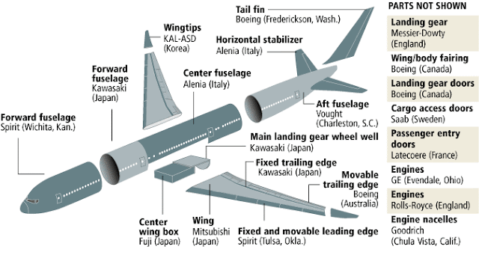
The Global Partners of 787
Source: Boeing 787 Dreamliner Assembly [4]

What has happened to 787?
In this year 2013, many incidents occurred. The most fatal one is the fire breakout from battery. Currently, Federal Aviation Administration (FAA) is investigating the cause. While this is still unknown, it is suspected to be due to the buttery made by Japanese manufacturer or the connection of the wire in the final assembly process[3]. After this incident, FAA has ordered air carriers to stop all the operation of 787 and Boeing halted 787 deliveries[2]. This case can be seen as a matter of the new product development in global supply chain.
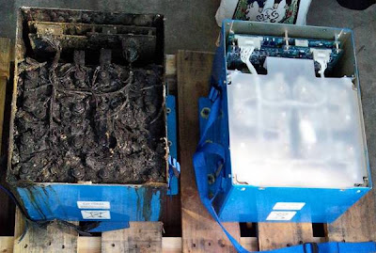
The damaged main lithium-ion battery
Source: Los Angeles Times 1/22 [1]

The prospect for the solution

Finding alternative parts is difficult for products, which adopt the built-to-order system and use new technology. Regarding 787, there are few alternative parts since each part has been developed for this project by a specific supplier. If they have an alternative part, it helps them to solve the problem. For example, they can experiment comparing the battery of 787 with another one in order to investigate the cause of the incident. Unfortunately, since the parts of 787 are the most advanced ones, it seems to take a lot of time to solve this issue.

Questions

- When / How could this project consider alternative suppliers during constructing supply chain?
- Who should be responsible for this incident?
787 has been developed as an international joint venture project.

