Elon Musk to Workers: Spend 40 Hours in the Office, or Else
In emails to workers at SpaceX and Tesla, Mr. Musk said they were required to spend a minimum of 40 hours a week in the office.

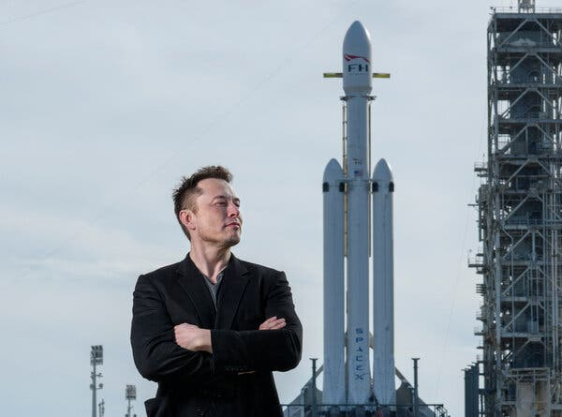
In an email to SpaceX employees, Elon Musk said he would fire workers who did not spend “a minimum of 40 hours in the office per week.”Credit...Todd Anderson for The New York Times

By Ryan Mac
- June 1, 2022
Elon Musk is demanding that his workers return to the office.
Mr. Musk, the world’s richest man, sent a pair of similar memos on Tuesday to push his employees at SpaceX, the rocket company he runs, and Tesla, the electric carmaker he leads, to spend time in the office.
In his email to SpaceX employees, Mr. Musk told workers that they were required to “spend a minimum of 40 hours in the office per week.” Those who did not do so would be fired, he wrote in the memo, which was obtained by The New York Times.
“The more senior you are, the more visible must be your presence,” Mr. Musk said. “That is why I spent so much time in the factory — so that those on the line could see me working alongside them. If I had not done that, SpaceX would long ago have gone bankrupt.”
In his memo to Tesla’s executive staff, which was posted by two pro-Tesla Twitter accounts and which the billionaire appeared to confirm, Mr. Musk also wrote that “anyone who wishes to do remote work” must be in the office for a minimum of 40 hours a week. Those who decline should “depart Tesla,” he added.
Image
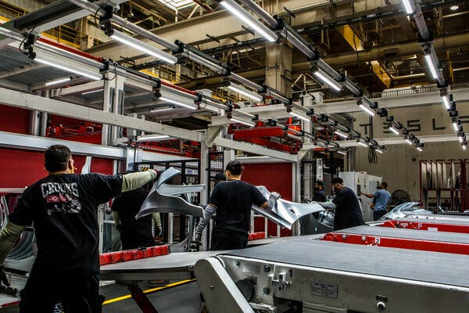
Workers at the Tesla factory in Fremont, Calif. Mr. Musk told Tesla’s executive staff that members should “depart” the company if they did not work in the office for a minimum of 40 hours a week.Credit...Christie Hemm Klok for The New York Times

With his twin notes, Mr. Musk waded directly into a fractious debate over the right way for corporations to bring workers back to the office during the coronavirus pandemic. Over the past couple of years, Apple, Meta, Microsoft and many other companies have announced and then delayed return-to-office dates as coronavirus surges have complicated plans. Remote work has become normalized.
The issue has become more fraught as coronavirus vaccinations have increased and an abatement of the pandemic seemed to be near. Some companies began saying they expected workers to return to the office. Still, plans have continued to fluctuate. Apple last month suspended its requirement that employees return to the office in May for at least three days a week because of a resurgence of Covid-19 cases. Airbnb recently told its employees that they never had to return to the office.

A New Office Culture

The past two years have changed the way we work in profound ways.
- Conference Rooms: These once-boring spaces are getting a reboot, with more democratic designs and cozier spaces.
- Change of Scenery: To make the return to work more appealing, some companies are picking up their offices and relocating them closer to where their employees live.
- Unlimited Vacation: Goldman Sachs is among several companies letting workers take as much time off as they want. That means no more unused days — and no need to pay them out later.
- A Puzzling Situation: As the uncertainty brought on by a new Covid wave complicates companies’ hybrid arrangements, leaders are left scratching their heads.
Mr. Musk, Tesla and SpaceX did not return requests for comment.
Many employees at Tesla and SpaceX had already been back in the office to some extent. In 2020, as “nonessential” workplaces in California closed their doors during the early days of the pandemic, SpaceX’s headquarters in Hawthorne, Calif., used its exemption as a government contractor to remain open. In a March 2020 email, which was earlier reported by BuzzFeed News, Mr. Musk told SpaceX employees that they had a higher risk of being killed in a car crash than dying from the coronavirus.
In May 2020, Mr. Musk also attacked local officials in the San Francisco Bay Area for not letting him reopen Tesla’s factory in Fremont, Calif. Tesla sued Alameda County, where the factory is situated, and reopened it anyway, in defiance of health officials’ instructions.
Tesla, which had more than 99,000 employees at the end of last year, has moved its headquarters to Austin, Texas, from Palo Alto, Calif., though it still has a significant manufacturing and operational presence in California. SpaceX employs about 12,000 people, Mr. Musk said in a recent interview.
Nick Bloom, an economics professor at Stanford University, said Mr. Musk’s directives to employees at SpaceX and Tesla were among the strictest of tech companies. Many tech companies have instead considered hybrid models in which employees can work from home for part of the time, he said.
Mr. Bloom said he expected SpaceX and Tesla to lose about 10 percent to 20 percent of their current work forces and for recruiters to try to poach employees by offering jobs with more flexible work options.
Many Tesla and SpaceX employees who work in cutting-edge tech may believe in Mr. Musk, but there are also people “who are in more common activities like I.T., finance, H.R. and payroll,” Mr. Bloom said. “They may say: ‘I’m not designing cars. I’m doing the payroll of employees, and I can do that somewhere else.’”
Annie Dean, the head of distributed work for Atlassian, an Australian software company, called Mr. Musk’s view “outdated.”
“This mind-set is regressive and discounts the last two years of collaborative, digital-first work,” said Ms. Dean, who was a former head of remote work at Meta, the owner of Facebook, in an email.
Mr. Musk has long been known as a demanding boss. At times, he tried setting an example for hard work, taking meetings late into the night, sending emails at all hours and even sleeping at the Tesla factory to help ramp up production in 2018.
It is unclear if Mr. Musk will adhere to his own rules of spending 40 hours a week in Tesla’s and SpaceX’s offices. He is rarely in the office and often travels, said two people who have worked with him and who spoke on the condition of anonymity. They expressed concerns about how the return-to-office policies would affect recruiting and retention at the companies.
Mr. Musk is also closing a $44 billion deal to buy Twitter. He has not said what he expects of Twitter employees in terms of time spent in the office. In 2020, Jack Dorsey, Twitter’s chief executive at the time, informed employees that many of them would be allowed to work from home permanently.
Adrian Zamora, a Twitter spokesman, said Twitter had no plans to change its policy on flexible work.
In his email to SpaceX employees on Tuesday, Mr. Musk suggested that companies that didn’t require workers to return to the office would not be able to ship “a great new product.”
“SpaceX has and will create and actually manufacture the most exciting and meaningful products of any company in space,” he said. “This will not happen by phoning it in.”
Cade Metz contributed reporting.

