Kiribati, the first country rising sea levels will swallow up as a result of climate change
#nature
Global warming is causing glaciers and ice sheets to melt. The average sea level has risen 3.2 mm/year since 1993. This is catastrophic for islands and coastal regions. Especially in places like Kiribati, an idyllic Pacific atoll nation that seems destined to become the first victim of climate change.
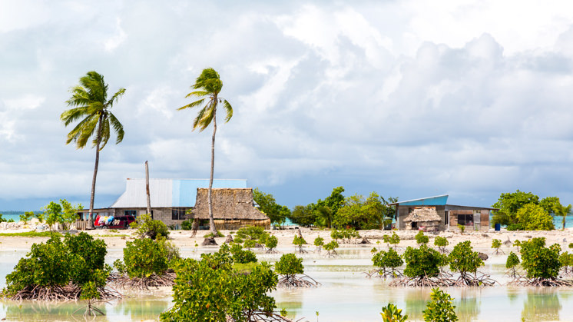
Outskirts of South Tarawa, Kiribati's capital.
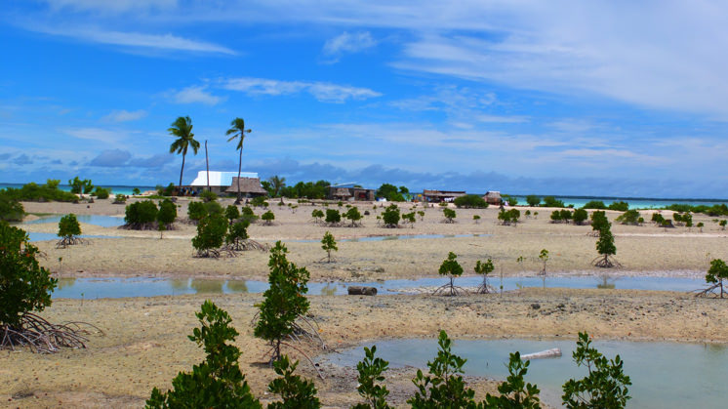
Outskirts of South Tarawa, Kiribati's capital.
accesibilidad.navegacionaccesibilidad.navegacion
A typical postcard paradise. A group of 33 atolls located in the central Pacific between Hawaii and Australia. Stilt houses on the beach. Twelve different words for coconut, depending on their level of ripeness. Fishermen in sarongs collect shellfish at low tide. This is Kiribati. The first country that will be swallowed up by the sea as a result of climate change. Global warming is melting the polar icecaps, glaciers and the ice sheets that cover Greenland, causing sea levels to rise. It is estimated sea levels have risen an average of 3.2 mm per year since 1993, according to the Fifth Assessment Report of the United Nations Intergovernmental Panel on Climate Change (IPCC, 2018).
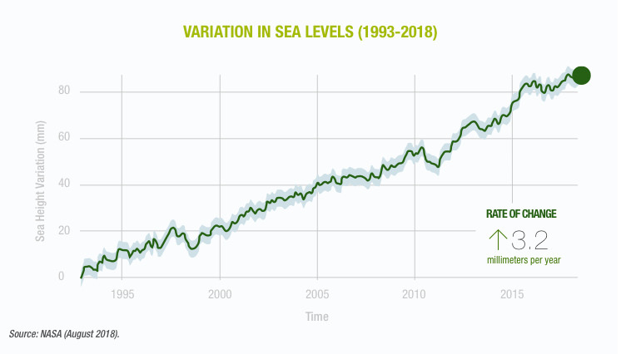
Variation in sea levels (1993-2018).
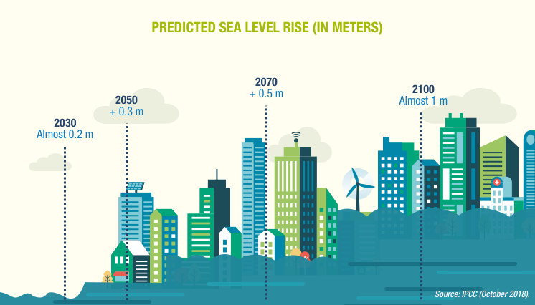
Predicted sea level rise.
accesibilidad.navegacionaccesibilidad.navegacion
This phenomenon is proving to be catastrophic for many coastal regions, especially places like Kiribati, whose entire territory is below two metres above sea level (apart from the volcanic island of Banaba).

WATER: FROM ALLY TO ENEMY
Half of Kiribati's more than 100,000 inhabitants live in the capital, South Tarawa, a narrow strip of land that lies between the Pacific and an enormous lagoon that depends on a freshwater lens. Life in Kiribati has always revolved around water. It's everywhere you look, always on the horizon. Children play in the water from a young age. It provides them with fish and a means to water their crops. But now, all they can do is look on as the marawa (sea in Gilbertese) turns against them for the first time.
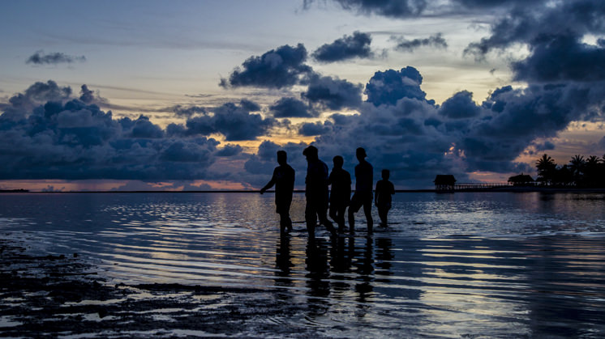
A group of people cross Tarawa Lagoon in Kiribati.
As far back as 1989, a UN report on the greenhouse effect listed Kiribati as one of the countries at risk from rising sea levels. Ten years later, two of its uninhabited islands, Abanuea and Tebua Tarawa (the latter used by fisherman) disappeared under the waves. Now, storm surges cause the sea to invade the land increasingly more often, contaminating freshwater reserves, killing crops and flooding homes.
Isolated from the world's problems, the people of Kiribati never imagined that they would become the first victim of climate change. Responsible for just 0.6% of world greenhouse gas emissions, Kiribati has publicly asked for policies and initiatives aimed at reducing polluting emissions to be increased. The country's former president, Anote Tong, has spent the last decade travelling the globe to alert the world to Kiribati's plight and try to find solutions to the imminent catastrophe.

DOES KIRIBATI HAVE A FUTURE?
Kiribatians have already begun to emigrate in response to what they believe to be an unavoidable situation. Others cling on to their land, looking for temporary solutions: residents have begun building walls out of coral rocks which are then destroyed by the high tide. Some towns have shifted a few metres inland, and mangroves have been planted to protect the soil from erosion and mitigate storm surges. If the predictions are accurate, the atoll of Tarawa will be uninhabitable within a generation.
The possibility has also been discussed of building an enormous floating platform, similar to those used by petroleum companies, or temporary sea defences; however, both options have been ruled out due to their high cost—the platform would cost around 2 billion dollars, which is 10 times Kiribati's GDP.
In search of a more realistic solution, the Kiribati government has bought land in Fiji to grow crops and possibly even serve as somewhere to evacuate the country's entire population if the worst does happen. At the same time, the World Bank has argued that Australia and New Zealand should allow open migration of people displaced by climate change from Kiribati and other Pacific islands threatened by the sea. Until now, only the New Zealand government has responded to the needs of Kiribatians, allowing 75 people to migrate to New Zealand per year.
The reality is that this problem is not endemic to the Pacific. Kiribati could just be the first domino to fall. If the ice sheets covering Greenland melt completely, sea levels would rise approximately seven metres, and cities like London and Los Angeles would disappear.
Climate change is accelerating the sixth extinction
We share the need to move towards a 1.5 ºC scenario with robust policies
The Iberdrola group, a world benchmark in the fight against climate change

