Notes
Forecasting

1. The Markov Analysis: is a type of analysis that allows us to predict the future by using the state probabilities and a Matrix of Transition Probabilities. Markov chain is a mathematical system that experiences transitions from one state to another according to certain probabilistic rules: Matrix of Transition Probabilities. There is a finite number of possible states, and the probability of changing states remains unchanged over time.
2. Delphi Method: this iterative group process allows experts, who may be located in different places, to make forecasts based on individual judgments. There are three different types of participants: decision makers, staff personnel, and respondents.
3. Forecasting Error: The difference between the actual and forecasted outcomes.
4. MAD: is a technique for determining the accuracy of a forecasting model by taking the average of the sum of absolute deviations between the forecasted and the actual results. MAD: measures the average magnitude of the forecast errors for a model.
5. Multiple regression model: a regression model that has more than one independent variables. Adding another independent variable turns a simple regression model into a multiple regression model. There is always one dependent variable.
6. Scatter Plots: two-dimensional, time-based plots showing the values for the joint occurrence of two variables. The scatter plot many be used to graphically represent the relationship between two variables. It is also known as a scatter diagram. They are shown on the x-y charts.
7. Weighted Moving Average: a moving average forecasting method that places different weights on past values. It is a subjective, more complex, forecasting technique.

8. Flowchart: is a picture of the separate steps of a process that is sequential or a parallel or parallel. It is a generic tool that can be adapted for a wide variety of purposes, and can be used to describe various processes, such as a manufacturing process, an administrative, service process, a project plan, or a business process flow. It is a graphical representation of the logic of a simulation model that will enable identification of single points of failure or causes of process slowdowns.
9. Consumer Market Surveys: are seldom always reliable. Consumers are not rational, cannot explain what they would buy. When they see it, they will know whether they like it or not.
10. Forecasting software: is just a tool no matter how sophisticated it is. Ultimately, humans make decisions. Artificial intelligence may change all of this.
11. Monte Carlo Simulation: this method is widely used in design of simulation programs. Monte Carlo simulations are used to model the probability of different outcomes in a process that cannot easily be predicted. It is a technique used to understand the impact of risk and uncertainty in prediction and forecasting models.
12. Perfect Forecasting Model: no single forecasting method is superior. Whatever works best should be used. A combination of suitable methods would be best.
13. Least-Square Criterion (Method): the criterion for determining a regression line that minimizes the sum of squared residuals. A procedure used in trend projection and regression analysis to minimize the squared distances between the estimated straight line and the observed values. Assumes that relationship between variables is linear and it applies only to the sample being analyzed.
14. Coefficient of Correlation: a quantitative measure of the strength of the linear relationship between two variables. The correlation ranges from -1.0 to +1.0. A correlation of +/1 indicates a perfect (positive or negative) linear relationship, whereas a correlation of 0 indicates no linear relationship. Its symbol is “r.”
15. Time-series Models: models that forecast using only historical data. This type of “data points” cannot be changed and are assumed to be “perfect.”

16. Moving Average: smooth out variations when forecasting demands are fairly steady. Moving averages have two problems: the larger number of periods may smooth out real changes, and they do not pick-up trends. Moving averages: the successive averages of n consecutive values in a time series. Data points within the span of the moving average calculations are weighted equally.
17. Qualitative Models: qualitative models are logic and judgement (experience and acumen) based. They are not based on numerical values as opposed to the quantitative models. They also incorporate such factors as the decision maker’s intuition, emotions, and personal value system.
18. Regression Analysis: a forecasting procedure that uses the least squares approach on one or more independent variables to develop a forecasting model. It enables predictive analysis based on the straight-line extrapolation. There can be more than one independent variables.
19. Random Numbers: a variable that assigns a numerical value to each outcome of a random experiment or trial. These numbers are randomly generated to ensure that there is no built-in bias.
20. Decision Making: all major business decisions should be made only after a simulation program is run and the output of that program is analyzed. Nobody can predict the future and humans have difficulty dealing with ambiguity.
21. Bias: a technique for determining the accuracy of a forecasting model by measuring the average error and its direction. That is the variations around the mean. A forecasting model is biased when it is produces a forecast that is consistently higher or consistently lower than actual values of a time series on which this forecast is based.
22. Causal Models: a representation of an actual system using either a physical or a mathematical representation. They incorporate the variables or factors that might influence the quantity being forecasted into the forecasting model and show a cause-effect relationship between variables.
23. The Jury of Executive Opinion: this method takes the opinions of a small group of high-level managers, often in combination with statistical models, and results in a group estimate of demand. It can lead to so called “’group think”
24. Model Specifications: the process of selecting the forecasting technique to be used in a particular situation.
25. Model Fitting: the process of determining how well a specified model fits past data.
26. Model Diagnosis: the process of determining how well a model fits past data and how well the model’s assumptions appear to be satisfied.
27. Forecasting horizon: the number of future periods covered by a forecast. It is sometimes referred to as forecast lead time.
28. Forecasting period: the unit of time for which forecasts are to be made.
29. Forecasting Interval: the frequency with which new forecasts are prepared.
30. Linear trend: a long-term increase or decrease in a time series in which the rate of change is relatively constant. A trend line is a regression equation with time as the independent variable. Typically, it measures the behavior of one variable overtime. It is a time-series forecasting method that fits a trend line to a series of historical data points and then projects the line into the future for forecast.
31. Cyclical Components: a wave-like pattern within the time series that repeats itself throughout the time series and has a recurrence period of more than one year. It is used to analyze and predict economic and business cycles. The pattern of this cyclical components will differ from industry to industry.
32. Random Component: changes in time-series data that are unpredictable and cannot be associated with a trend, seasonal, or cyclical component.
33. The time-series: value to which all other values in the time series are compared. This index number for the base period is defined as 100.
33. Exponential smoothing: a time series and forecasting technique that produces an exponentially weighted moving average in which each smoothing calculation or forecast is dependent on all previously observed values. The smoothing constant α allows managers to assign weight to recent data and to apply “what-if” analysis. It has a value ranging from 0 to 1, but most likely will be in the range between 0.1 and 0.3. Excel uses the “damping factor” called beta.

35. Regression Slope Coefficient: the average change in the dependent variable for a unit increase in the independent variable. The slope coefficient may be positive or negative, depending on the relationship between the two variables.
36. Coefficient of Determination: the portion of the total variation in the dependent variable that is explained by its relationship (strength) with the independent variable. The coefficient of determination is also called R-squared. The value it will assume will be between 0 and 1.
37. Interaction Effect in a Regression Model: the interaction effect in a regression model occurs when the partial effect of the predictor variable on the response variable depends on the value of another predictor variable.
38. Dummy Variable: a variable that is assigned a value equal to either 0 or 1, depending on whether the observation possesses a given characteristics.
39. Simple Regression: the method of regression analysis in which a single independent variable is used to predict the dependent variable.
40. Multiple Regression: is an extension of simple regression analysis. A value of the dependent variable can be estimated using values of two or more independent variables.
41. Residual: the difference between the actual value of the dependent variable and the value predicted by the regression model.
42. Model: a representation of an actual system using either a physical or a mathematical format.
43. Seasonal Component: a wavelike pattern that is repeated throughout a time-series and has a recurrence period of at most one year. Seasonal variations are regular upward or downward movements in a time series that tie to the recurring events
44. Cyclical Component: a wavelike pattern within the time-series that repeats itself throughout the time series and has a recurrence period of more than one year.
45. Random Component: changes in time-series data that are unpredictable and cannot be associated with a trend, seasonal, or cyclical component.

46. Base Period Index: the time-series value to which all other values in the time series are compared. The index number for the base period is defined as 100. The base value is the value to which all other values in the time series are compared.
47. Forecast Bias: can be either positive or negative. A positive value indicates a tendency to over-forecast and vice versa.
48. Seasonal Index: a number used to quantify the effect of seasonality in time-series data.
49. The Aggregate Price Index: is an index that is used to measure the rate of change from a base period for a group of two or more items.
50. Forecasting: is the art and science of predicting future events. The forecast is the only estimate of demand until actual demand becomes known.
51. Economic Forecast: planning indicators that are valuable in helping organizations prepare medium to long-range forecasts.
52. Technological Forecast: long-term forecast concerned with the rate of technological change.
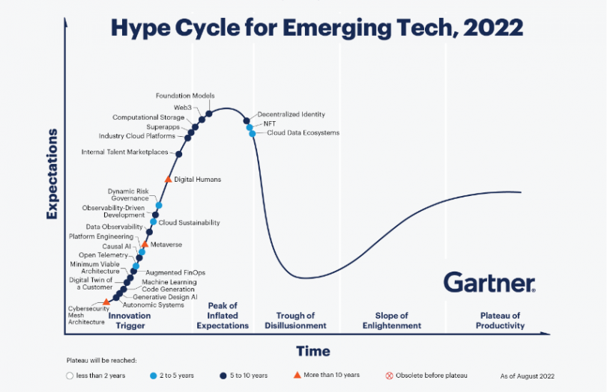

53. Demand Forecast: projections of a company’s sales for each time period in the planning horizon.
54. Forecast Complexity and Accuracy: forecasts are easy when demand is stable. But with trend, seasonality, and cycles considered, the job of forecasting is much more complex. Forecasts tend to be more accurate as they become shorter. Therefore, forecast error also tends to drop with shorter forecast.
55. Naïve Approach: a forecasting technique that assumes that demand in the next period is equal to demand in the most recent period.
56. Linear Regression Analysis: a straight-line mathematical model to describe the functional relationship between independent and dependent variables.
57. Standard Error of the Estimate: a measure of variability around the regression line-its standard deviation. Actual values. Using a tracking signal is a good way to make sure the forecasting system is continuing to do a good job.
58. Tracking Signal: a measurement of how well a forecast is predicting actual values.
59. Steps if Forecasting:
- Define the use of the forecast
- Select the items to be forecasted
- Decide on the time horizon of the forecast
- Select the forecasting model
- Gather the data needed to make the forecast
- Make the forecast
- Validate the outcome and iterate if needed
- Implement the results

60. Forecasting in the Service Sector: requires good short demand records, even as short as 15 minutes intervals. Demands during holidays or specific weather events may also need to be accurately tracked.

