Homework Set 2
EGR 310

- (5 pts) $1000 is borrowed for one year at 1.5% per month. If the same amount could be borrowed at 18% per year, how much could be saved? What is the nominal and effective rate for each investment alternative. (Chapter 3)

- (5 pts) If you invest $3000 into an account that compounds 7% continuously, what is the annual effective rate? (Chapter 3)

- (10 pts) You just bought a house for $500,000. You put 20% down and financed the rest over 20 years at 3% nominal interest. Assuming equal monthly payments over the term of the loan, what are the monthly payments? What is the effective rate? (Chapter 4)

- (10 pts) What would you need to invest today in an account that had a nominal rate of 12% compounded quarterly, if you wanted $9000 in 5 years? What would be the investment required if the account compounded monthly? What is the effective rate of each investment? (Chapter 3)

- (10 pts) Assume we receive $1200 at the end of each year for 6 years. What is the equivalent value of the cash flows at time period 0 assuming 5% interest? What is the equivalent value at the end of time period 6 assuming 5% interest? (Chapter 4)

- (10 pts) Assume the following cash flows: (Chapter 4)
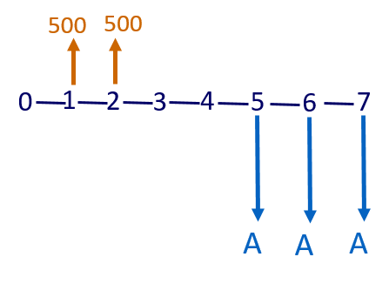
Assuming an 8% interest rate, what is A?

- (10 pts) The maintenance on a piece of equipment is $800 at the end of year 1 and increases $200/yr each year until the end of the 4 year life of the equipment. Assuming you could invest at 6%, what amount would you need today to cover all the maintenance costs in the future? (Chapter 4)

- (10 pts) Assuming you are earning $60,000/yr and expect a 3% raise every year for the next seven years. If you invest 10% of your salary each year into a 401K that returns 3% per year, what will the value of the 401K be after 7 years? (Chapter 4)

- (10 pts) Use Present Worth Analysis to determine which investment is best (which has the lowest present cost). Assume a 4% interest rate. (Chapter 5)

Year | Alt A | Alt B
0 | -$4,000 | -$2,000
1 | -$500 | -$500
2 | -$500 | -$800
3 | -$500 | -$1,100
4 | -$500 | -$1,400
5 | -$500 | -$1,700
6 | -$500 | -$2,000

- (10 pts) To maintain a gravesite requires $600/yr perpetually. What amount needs to be invested today at 5% interest to provide $600/yr perpetually? (Chapter 5)

- (10 pts) Use Net Present Worth Analyses to determine the best of the following 3 mutually exclusive investments. Assume a useful life of 8 years and interest rate of 7%: (Chapter 5)

 | Alt A | Alt B | Alt C
Initial Investment | $10,000 | $12,000 | $15,000
O&M Costs | $800 | $500 | $800
Annual Benefit | $2,200 | $2,400 | $3,000
Salvage Value | $3,000 | $4,000 | $5,000

